Captivate Simulations Storyboard

Guide Me Simulation

Using the IME

Image of title screen.

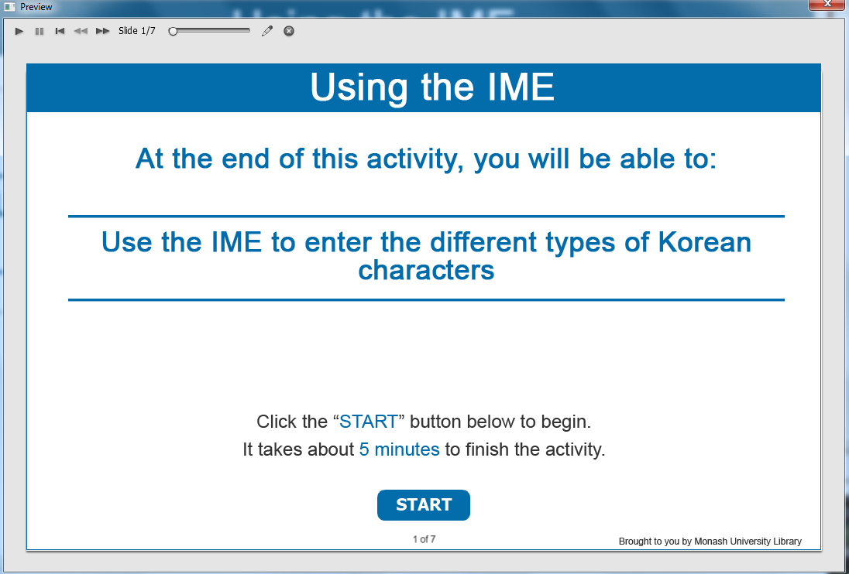

Information captions:
Using the IME.

Guide Me: At the end of this activity, you will be able to: Use the IME to enter the different types of Korean characters.

Instruction caption: Click the “START” button below to begin. It takes about 5 minutes to finish the activity.

Screen Step 1: Using the IME (how to activate the IME on your device)

Image of how to activate the IME on your device screen.

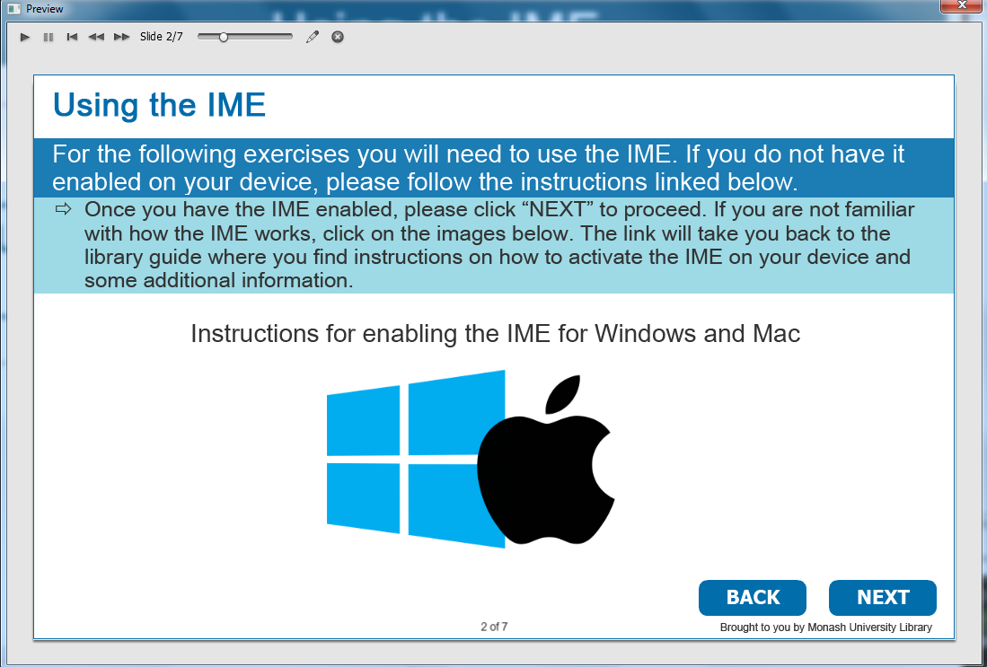

Information caption:
Using the IME.

Guide Me:
For the following exercises you will need to use the IME. If you do not have it enabled on your device, please follow the instructions linked below.

Instruction caption: Once you have the IME enabled, please click “NEXT” to proceed. If you are not familiar with how the IME works, click on the images below. The link will take you back to the library guide where you find instructions on how to activate the IME on your device and some additional information.
Instructions for enabling the IME for Windows and Mac (http://guides.lib.monash.edu/finding-non-english-resources/korean#s-lib-ctab-7960776-1).

Optional buttons: Click BACK or NEXT.

Screen Step 2: Input Korean character (한글, 漢字) with the IME

Image of the input Korean character (한글, 漢字) with the IME screen.

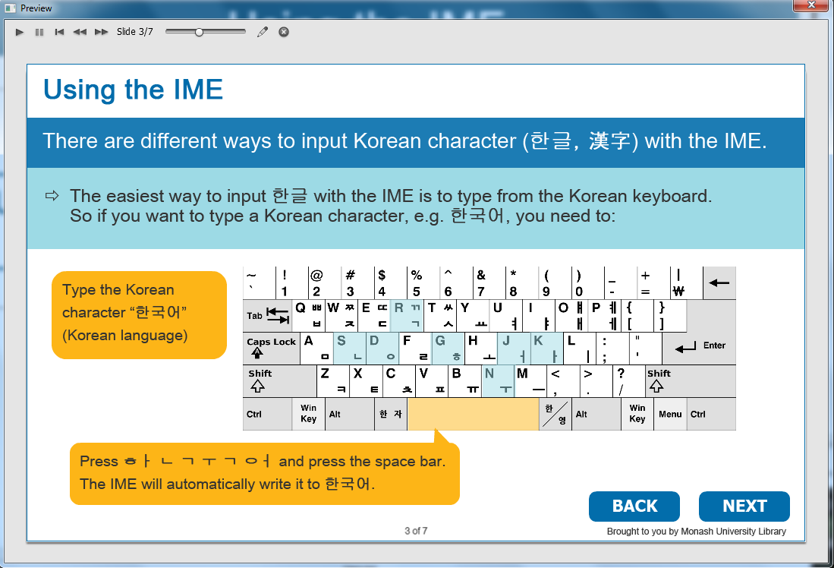

The relevant keys are highlighted.

Information caption:
Using the IME.

Guide Me:
There are different ways to input Korean character (한글, 漢字) with the IME. The easiest way to input 한글 with the IME is to type from the Korean keyboard. So if you want to type a Korean character, e.g. 한국어, you need to:

Instruction caption: Type the Korean character “한국어” (Korean language).
Press ㅎㅏ ㄴ ㄱ ㅜ ㄱ ㅇㅓ and press the space bar. The IME will automatically write it to 한국어.

Optional buttons: Click BACK or NEXT.

Screen Step 3: Using the IME (how to activate the IME on your device)

Image of type Korean using the Han/Eng toggle from the IME bar screen.

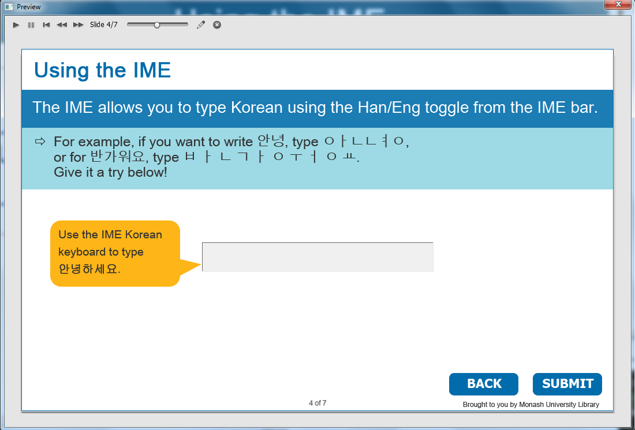

Information caption:
Using the IME.

Guide Me:
The IME allows you to type Korean using the Han/Eng toggle from the IME bar. For example, if you want to write 안녕, type ㅇㅏㄴㄴㅕㅇ, or for 반가워요, type ㅂ ㅏ ㄴ ㄱ ㅏ ㅇ ㅜ ㅓ ㅇ ㅛ. Give it a try below!

Instruction caption: Use the IME Korean keyboard to type 안녕하세요.

Feedback caption: Well done! Click anywhere to continue.
Please try again and make sure you use the IME to type 안녕하세요 before clicking “SUBMIT”.

Optional buttons: Click BACK or NEXT.

Screen Step 4: Input Hancha by typing the Han Han’gŭl

Image of input Hancha by typing the Han’gŭl.

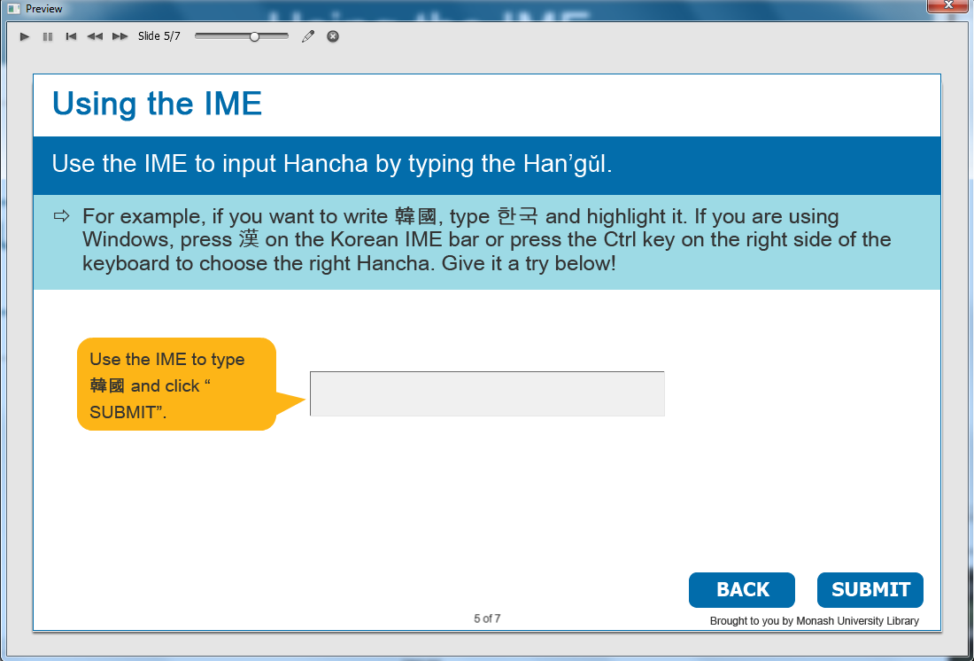

Information caption:
Using the IME.

Guide Me:
Use the IME to input Hancha by typing the Han’gŭl.

Instruction caption: For example, if you want to write 韓國, type 한국 and highlight it. If you are using Windows, press 漢 on the Korean IME bar or press the Ctrl key on the right side of the keyboard to choose the right Hancha. Give it a try below!
Use the IME to type 韓國 and click “SUBMIT”.

Feedback caption: Well done! Click anywhere to continue.
Please try again and make sure you use the IME to type 한국 and highlight the Hangul characters. Then press 漢 on the Korean IME bar or the Ctrl key on the right side of the keyboard to choose the right Hancha.

Optional buttons: Click BACK or NEXT.

Screen Step 5: Using the IME pad – HandWriting

Image of IME pad - HandWriting screen.

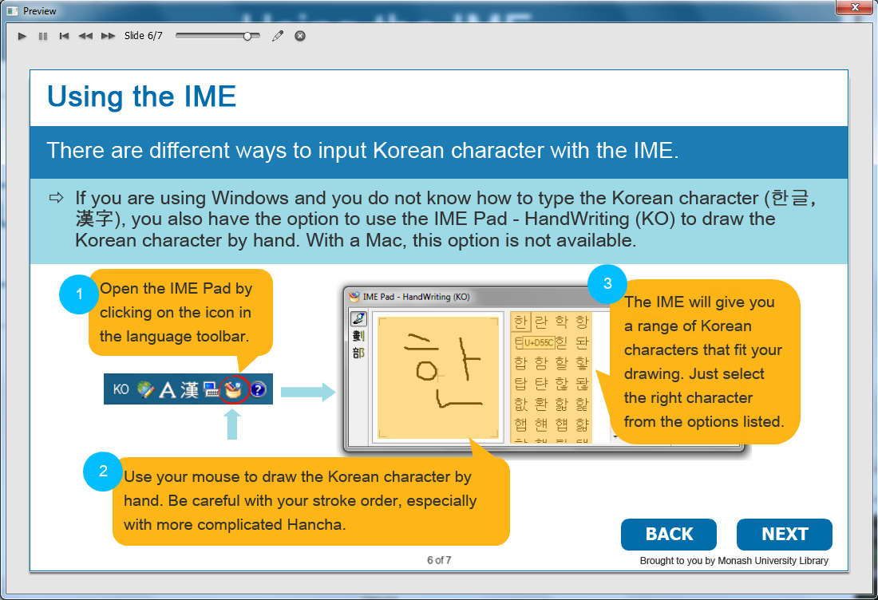

The handwrited한 and the range of Korean characters are highlighted.

Information caption:
Using the IME.

Guide Me:
There are different ways to input Korean character with the IME. If you are using Windows and you do not know how to type the Korean character (한글, 漢字), you also have the option to use the IME Pad - HandWriting (KO) to draw the Korean character by hand. With a Mac, this option is not available.

Instruction caption:
- Open the IME Pad by clicking on the icon in the language toolbar.
- Use your mouse to draw the Korean character by hand. Be careful with your stroke order, especially with more complicated Hancha.
- The IME will give you a range of Korean characters that fit your drawing. Just select the right character from the options listed.

Optional buttons: Click BACK or NEXT.

Screen Step 6: Well done!

Image of Well done screen.

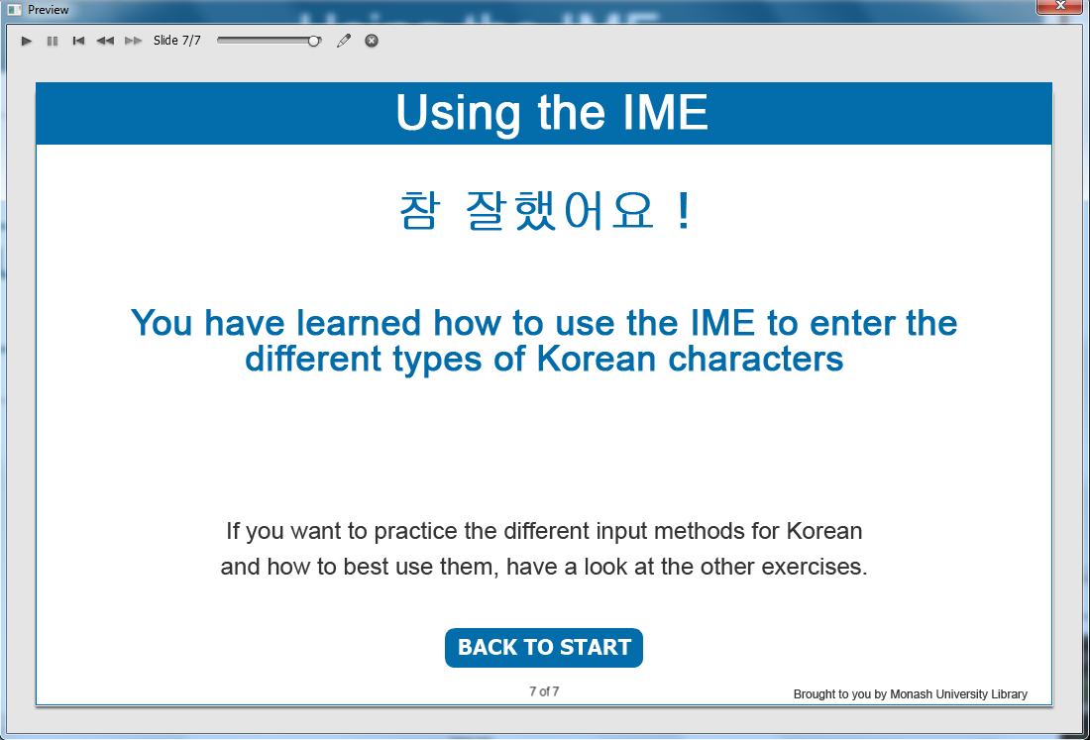

Information captions:
Using the IME
참 잘했어요 !
You have learned how to use the IME to enter the different types of Korean characters.
If you want to practice the different input methods for Korean and how to best use them, have a look at the other exercises.

Instruction caption: Click BACK TO START

