Captivate Simulations Storyboard

Guide Me Simulation

Korean Resources in Library Search

Image of title screen.

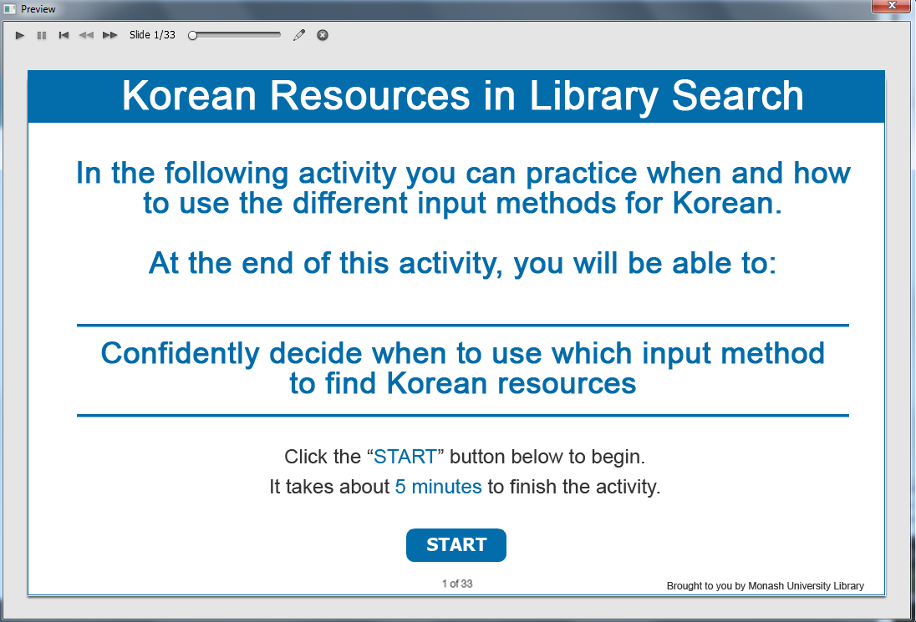

Information captions:
Korean Resources in Library Search.

Guide Me: In the following activity you can practice when and how to use the different input methods for Korean. At the end of this activity, you will be able to:
Confidently decide when to use which input method to find Korean resources.

Instruction caption: Click the “START” button below to begin. It takes about 5 minutes to finish the activity.

Screen Step 1: Basic Library Search

Image of Basic search screen.

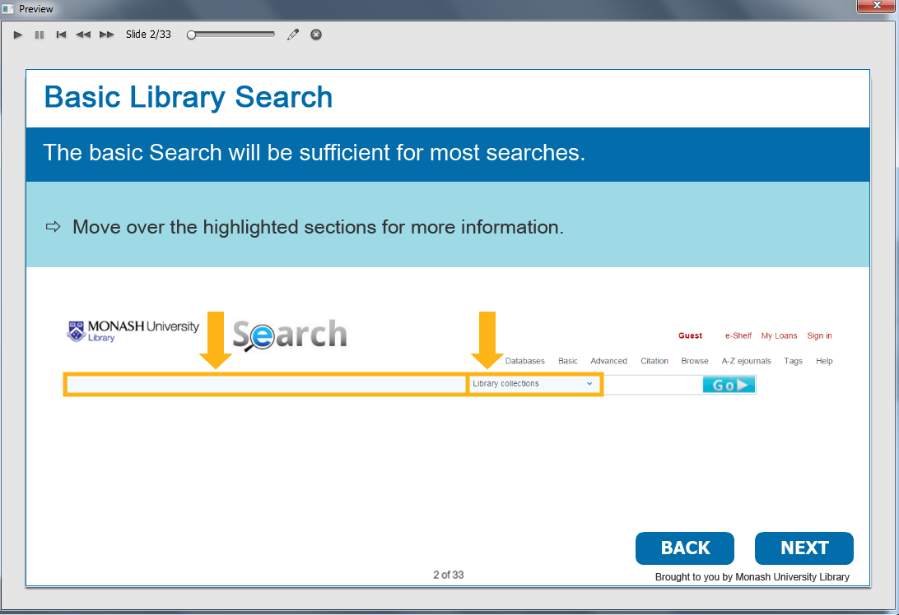

Information caption:
Basic Library Search.

Guide Me:
The Basic search will be sufficient for most searches.

Instruction caption: Move over the highlighted sections for more information.

[Rollover area] Type in your search term in the basic search field.
[Rollover area] Choose “Library collections” from the drop-down box to limit your search to items available in the library.

Optional buttons: Click BACK or NEXT.

Screen Step 2: Books in Basic Library Search by author

Image of the books in Korean by author.

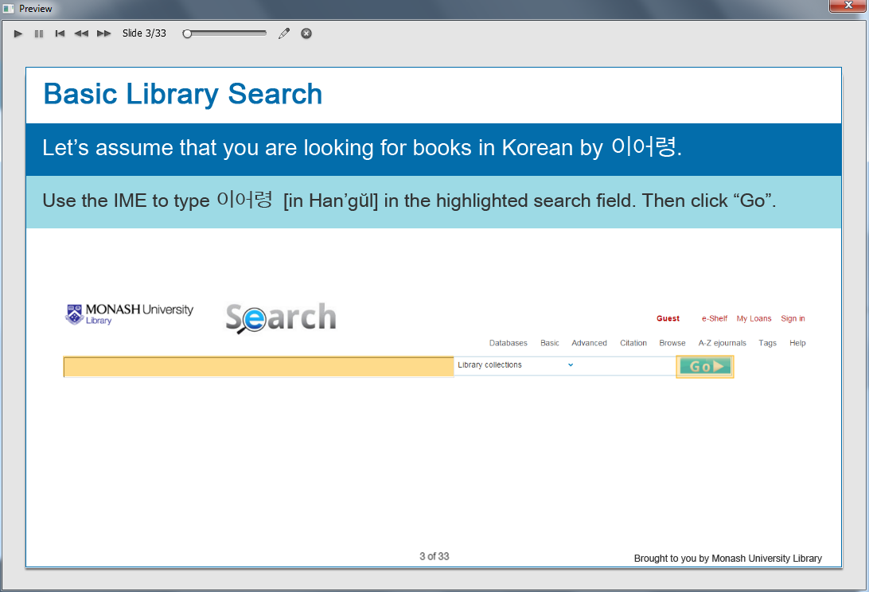

The search box is highlighted.

Information caption:
Basic Library Search.

Guide Me:
Let’s assume that you are looking for books in Korean by 이어령.

Instruction caption: Use the IME to type 이어령 [in Han’gŭl] in the highlighted search field. Then click “Go”.

Feedback caption: Incorrect. Make sure you type in the correct Han’gŭl for 이어령 [Yi Ŏ-ryŏng]

Optional buttons: Click BACK or NEXT.

Screen Step 3: Results of books in Basic Library Search by author

Image of the results screen of books in Korean by author.

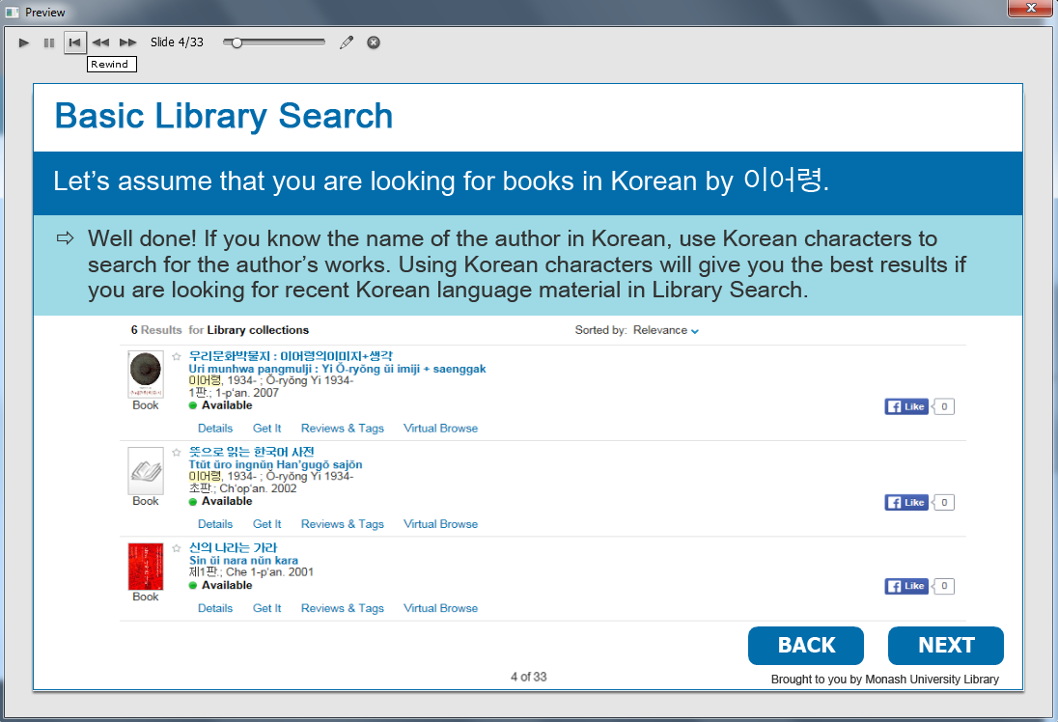

The total number of books found.

Information caption:
Basic Library Search.

Guide Me:
Let’s assume that you are looking for books in Korean by 이어령.

Well done! If you know the name of the author in Korean, use Korean characters to search for the author’s works. Using Korean characters will give you the best results if you are looking for recent Korean language material in Library Search.

Optional buttons: Click BACK or NEXT.

Screen Step 4: Advanced Library Search

Image of the Advanced Search function screen.

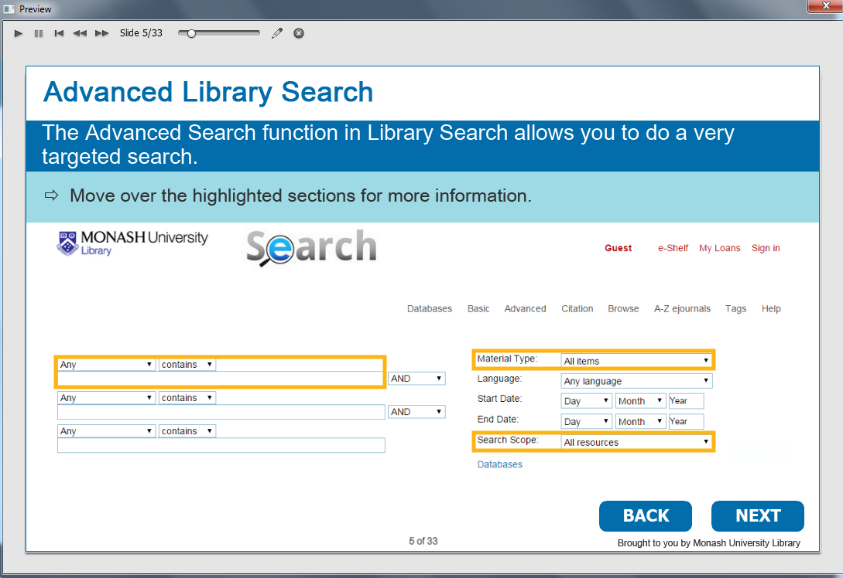

Information caption:
Advanced Library Search.

Guide Me:
The Advanced Search function in Library Search allows you to do a very targeted search.

Instruction caption: Move over the highlighted sections for more information.

[Rollover area] The drop-down menu allows you to limit your search. If you are looking for the author, select “as author/creator”.Then enter the name of the author.
[Rollover area] You can also limit your search to specific types of materials, e.g. books.
[Rollover area] Choosing “Library collections” will limit your search to material available in the library.

Optional buttons: Click BACK or NEXT.

Screen Step 5: Advanced Library Search by title

Image of Advanced Library Search by title screen.

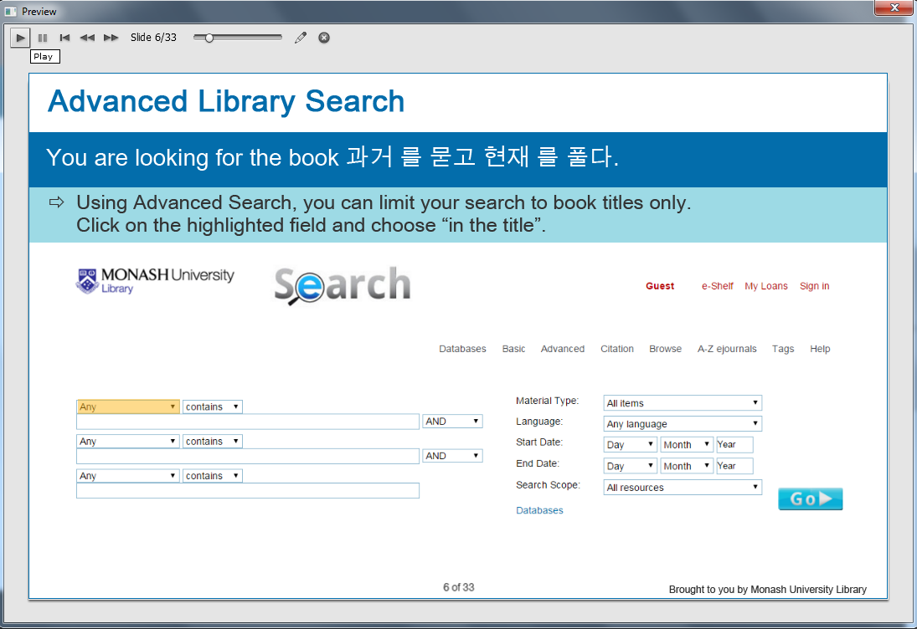

The “Any” is highlighted.

Information caption:
Advanced Library Search.

Guide Me: You are looking for the book 과거 를 묻고 현재 를 풀다.

Instruction caption: Using Advanced Search, you can limit your search to book titles only.
Click on the highlighted field and choose “in the title”.

Screen Step 6: Choose “in the title” in Advanced Library Search by title

Image of Advanced Library Search by title screen.

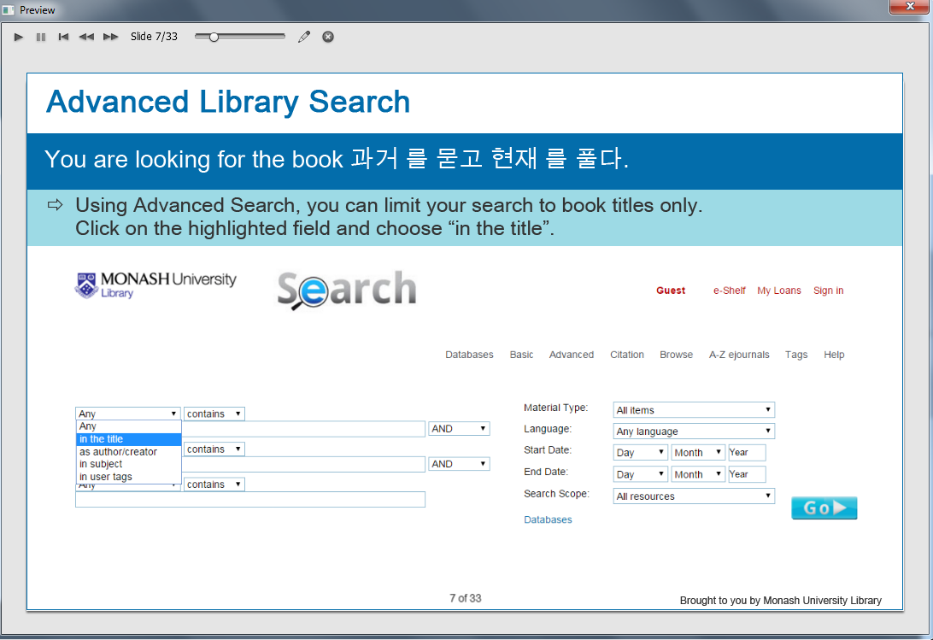

Information caption:
Advanced Library Search.

Guide Me: You are looking for the book 과거 를 묻고 현재 를 풀다.

Instruction caption: Using Advanced Search, you can limit your search to book titles only.
Choose “in the title”.

Screen Step 7: Material type in Advanced Library Search by title

Image of Advanced Library Search by title screen.

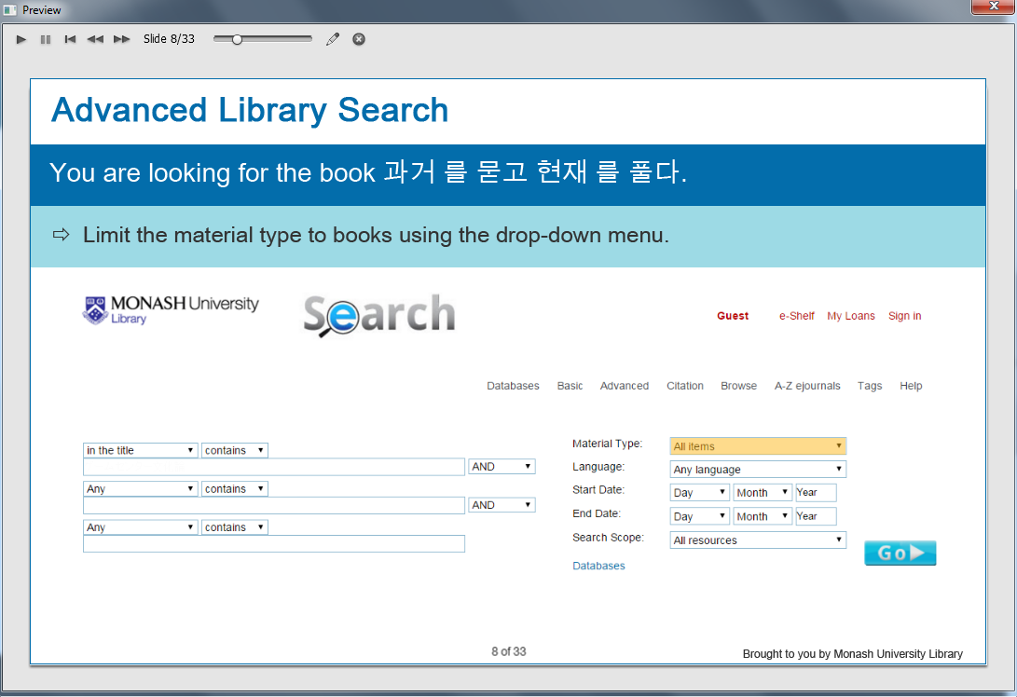

The “All items” is highlighted.

Information caption:
Advanced Library Search.

Guide Me: You are looking for the book 과거 를 묻고 현재 를 풀다.

Instruction caption: Limit the material type to books using the drop-down menu.
Click on the highlighted field.

Screen Step 8: Choose “Books” in Advanced Library Search by title

Image of Advanced Library Search by title screen.

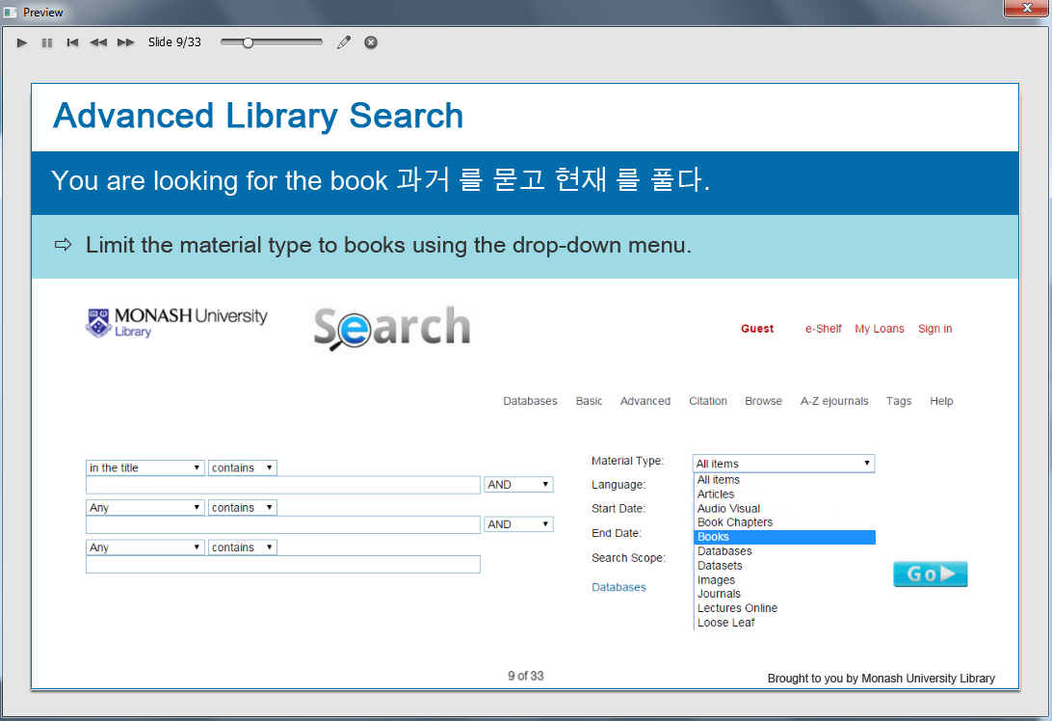

Information caption:
Advanced Library Search.

Guide Me: You are looking for the book 과거 를 묻고 현재 를 풀다.

Instruction caption: Limit the material type to books using the drop-down menu.
Choose “Books”.

Screen Step 9: Search scope in Advanced Library Search by title

Image of Advanced Library Search by title screen.

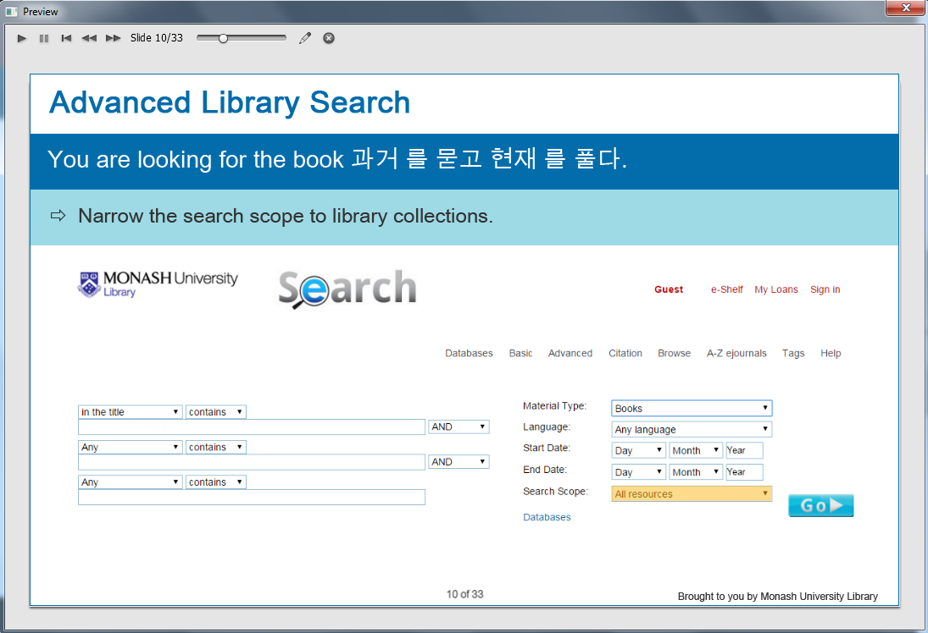

The “All resources” is highlighted.

Information caption:
Advanced Library Search.

Guide Me: You are looking for the book 과거 를 묻고 현재 를 풀다.

Instruction caption: Narrow the search scope to library collections.
Click on the highlighted field.

Screen Step 10: Choose “Library Collections” in Advanced Library Search by title

Image of Advanced Library Search by title screen.

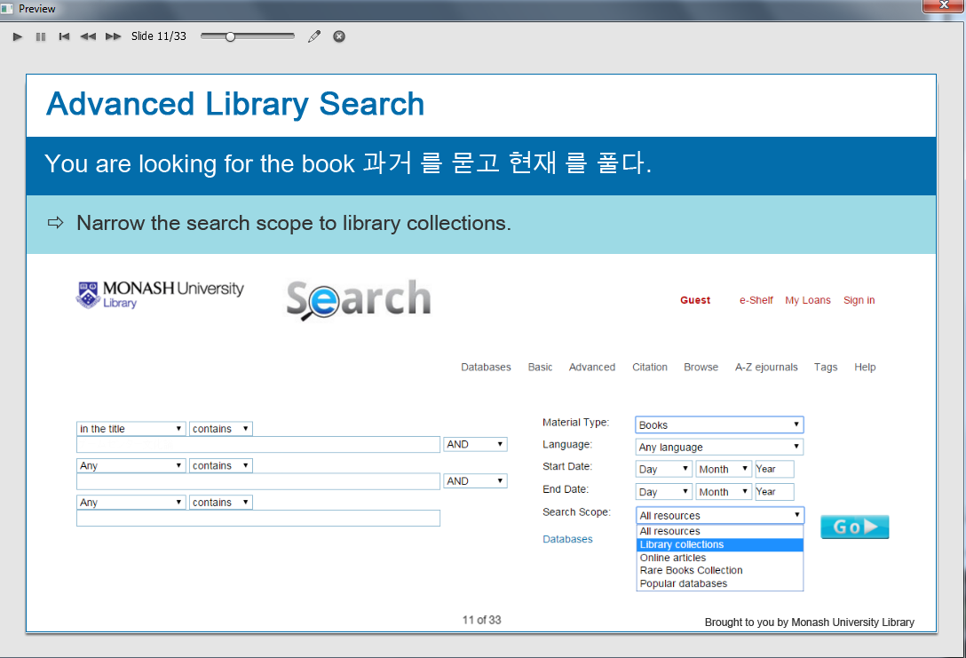

Information caption:
Advanced Library Search.

Guide Me: You are looking for the book 과거 를 묻고 현재 를 풀다.

Instruction caption: Narrow the search scope to library collections.
Choose “Library collections”.

Screen Step11: Enter your search term in Advanced Library Search by title

Image of Advanced Library Search by title screen.

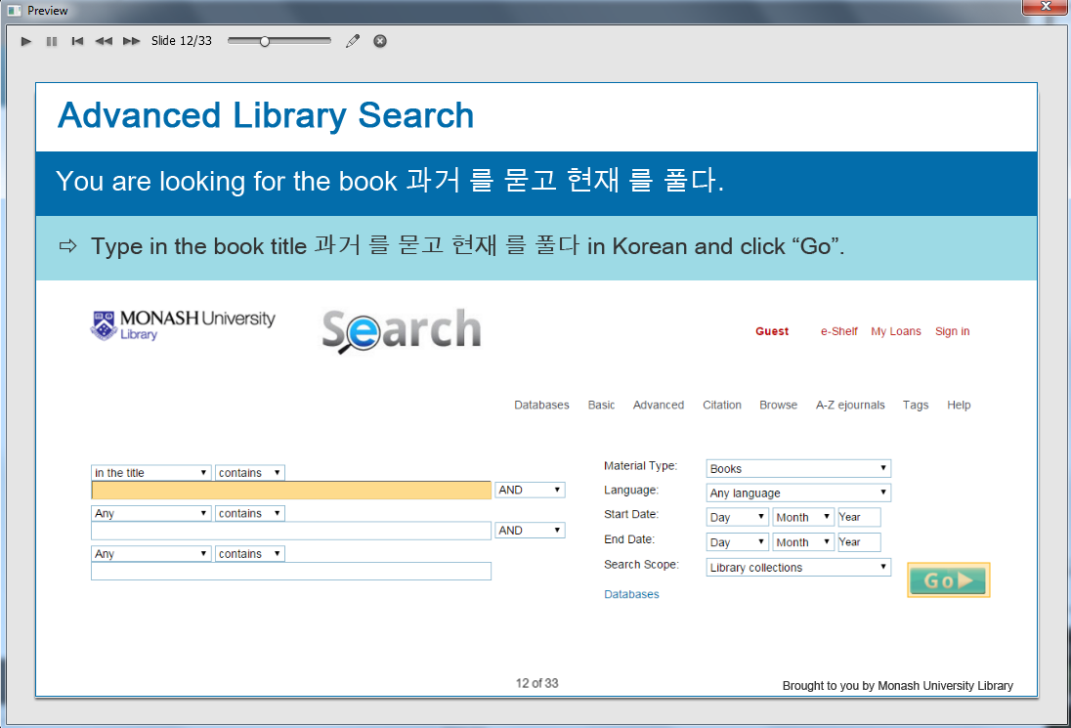

The search box is highlighted.

Information caption:
Advanced Library Search.

Guide Me: You are looking for the book 과거 를 묻고 현재 를 풀다.

Instruction caption: Type in the book 과거 를 묻고 현재 를 풀다 in Korean and click “Go”.

Feedback caption: Incorrect. Use the IME and check if you used the correct Korean characters.

Screen Step 12: View your search results by title

Image of the search results screen in Advanced Library Search by title.

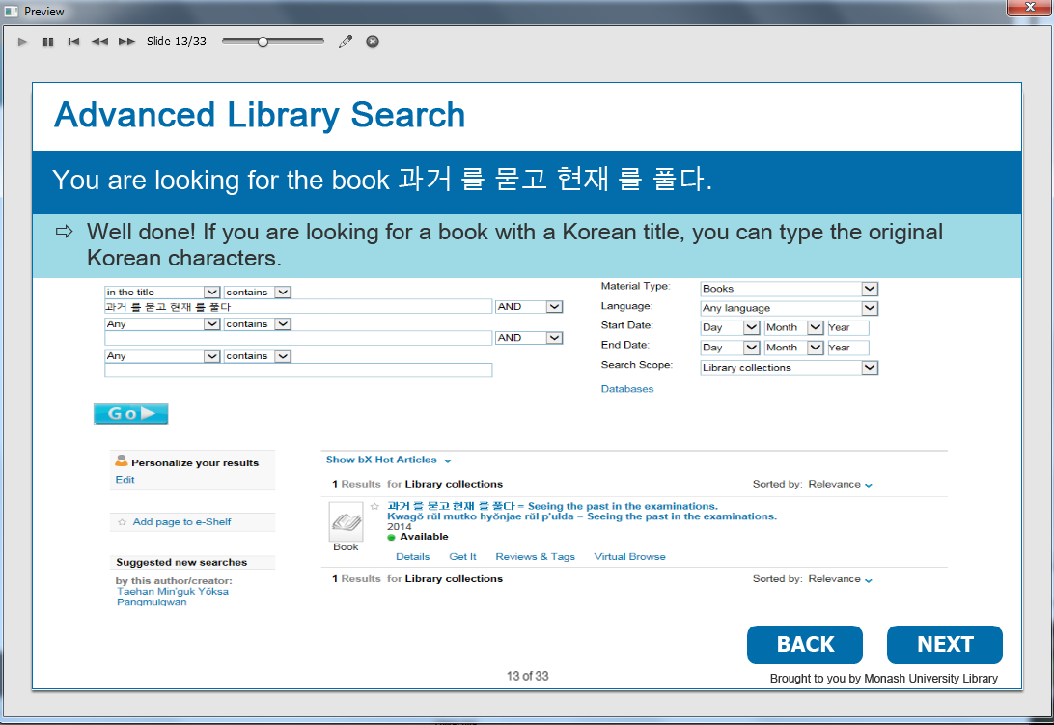

The book found.

Information caption:
Advanced Library Search.

Guide Me: You are looking for the book 과거 를 묻고 현재 를 풀다.

Instruction caption: Well done! If you are looking for a book with a Korean title, you can type the original Korean characters.

Optional buttons: Click BACK or NEXT.

Screen Step 13: Advanced Library Search by author

Image of the Advanced Library Search screen.

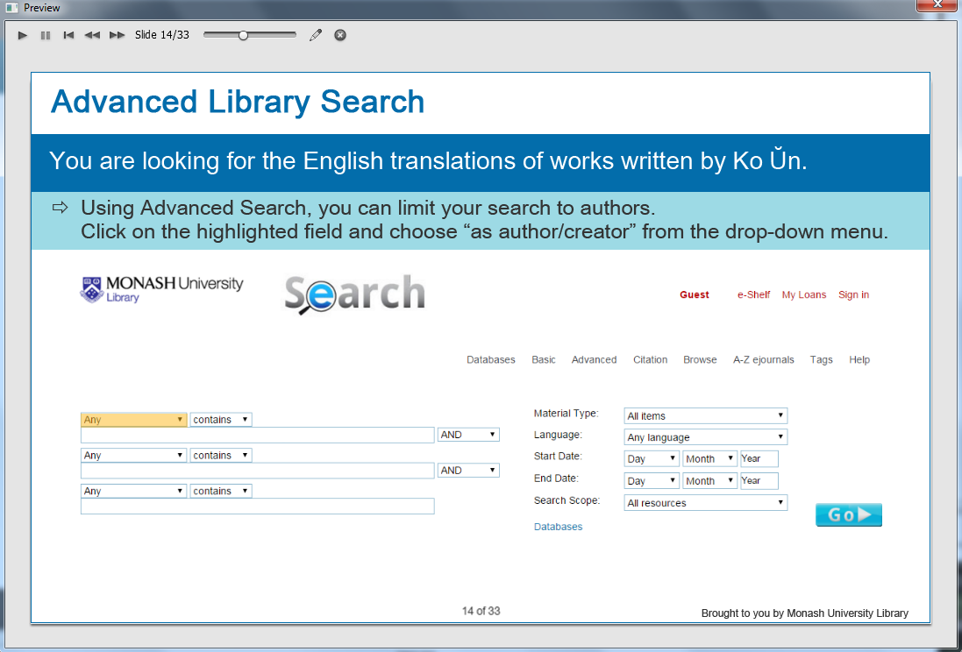

The “Any” is highlighted.

Information caption:
Advanced Library Search.

Guide Me: You are looking for the English translations of works written by Ko Ŭn.

Instruction caption: Using Advanced Search, you can limit your search by authors.
Click on the highlighted field and choose “as author/creator” from the drop-down menu.

Screen Step 14: Choose “as author/creator” in Advanced Library Search by author

Image of the Advanced Library Search screen.

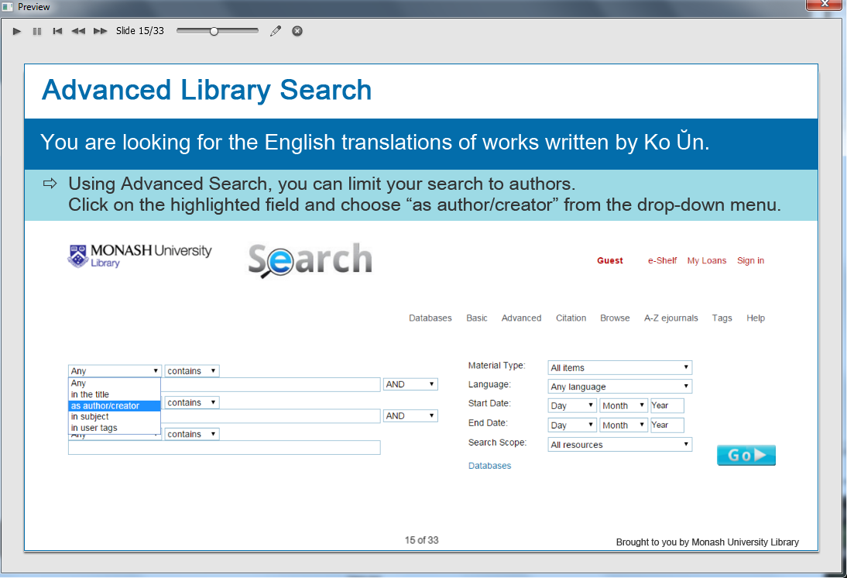

Information caption:
Advanced Library Search.

Guide Me: You are looking for the English translations of works written by Ko Ŭn.

Instruction caption: Using Advanced Search, you can limit your search by authors.
Click on the highlighted field and choose “as author/creator” from the drop-down menu.
Choose “as author/creator”.

Screen Step 15: Material type in Advanced Library Search by author

Image of the Advanced Library Search screen.

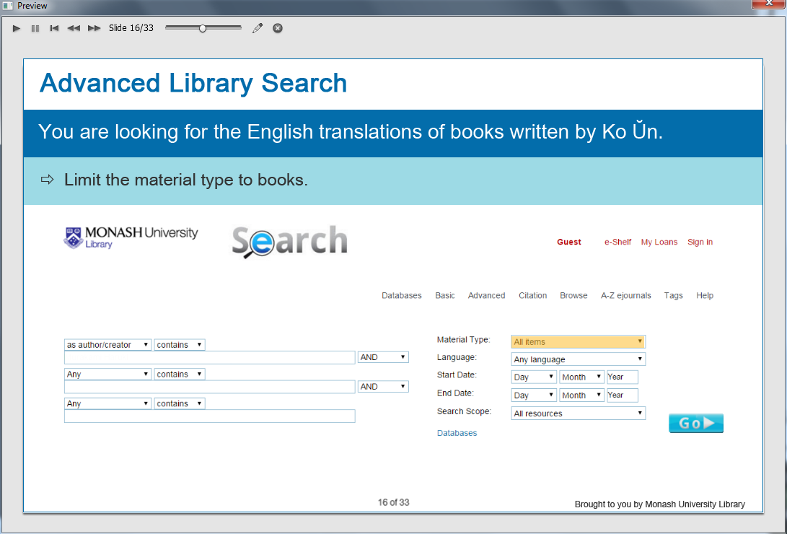

The “All items” is highlighted.

Information caption:
Advanced Library Search.

Guide Me: You are looking for the English translations of works written by Ko Ŭn.

Instruction caption: Limit the material type to books.
Click on the highlighted field.

Screen Step 16: Choose “Books” in Advanced Library Search by author

Image of the Advanced Library Search screen.

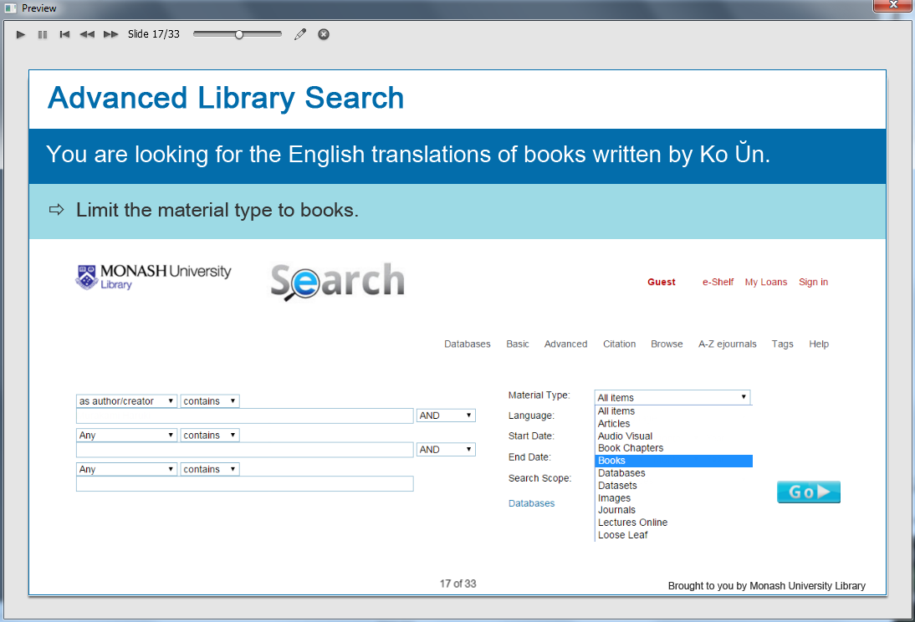

Information caption:
Advanced Library Search.

Guide Me: You are looking for the English translations of works written by Ko Ŭn.

Instruction caption: Limit the material type to books using the drop-down menu.
Choose “Books”.

Screen Step 17: Language in Advanced Library Search by author

Image of Advanced Library Search by author screen.

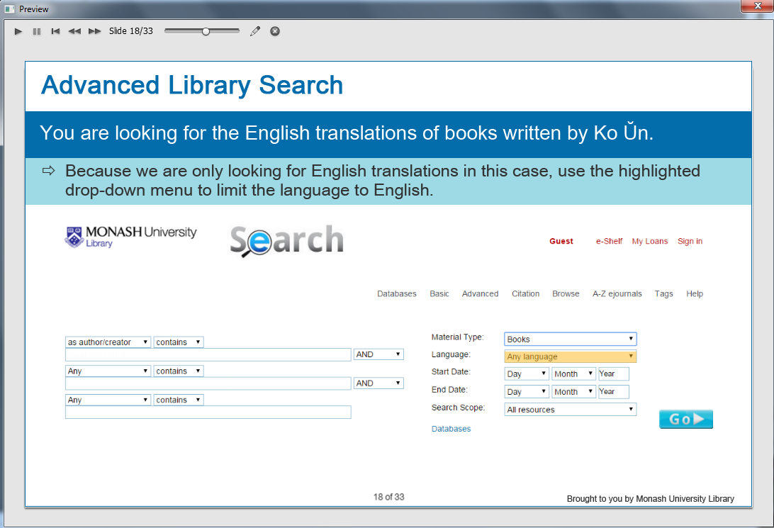

The “Any language” is highlighted.

Information caption:
Advanced Library Search.

Guide Me: You are looking for the English translations of works written by Ko Ŭn.

Instruction caption: Because we are only looking for English translations in this case, use the highlighted drop-down menu to limit the language to English.
Click the highlighted field.

Screen Step 18: Choose “English” in Advanced Library Search by author

Image of Advanced Library Search by author screen continue.

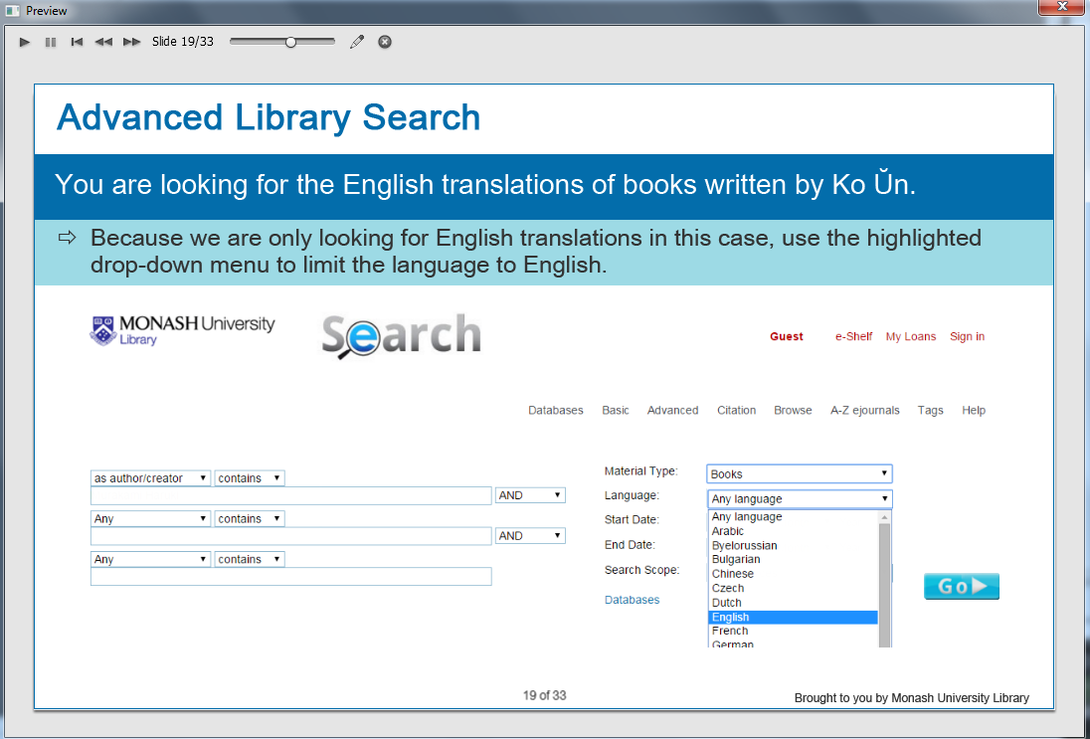

Information caption:
Advanced Library Search.

Guide Me: You are looking for the English translations of works written by Ko Ŭn.

Instruction caption: Because we are only looking for English translations in this case, use the highlighted drop-down menu to limit the language to English.
Choose “English”.

Screen Step 19: Search scope in Advanced Library Search by author

Image of Advanced Search by author screen.

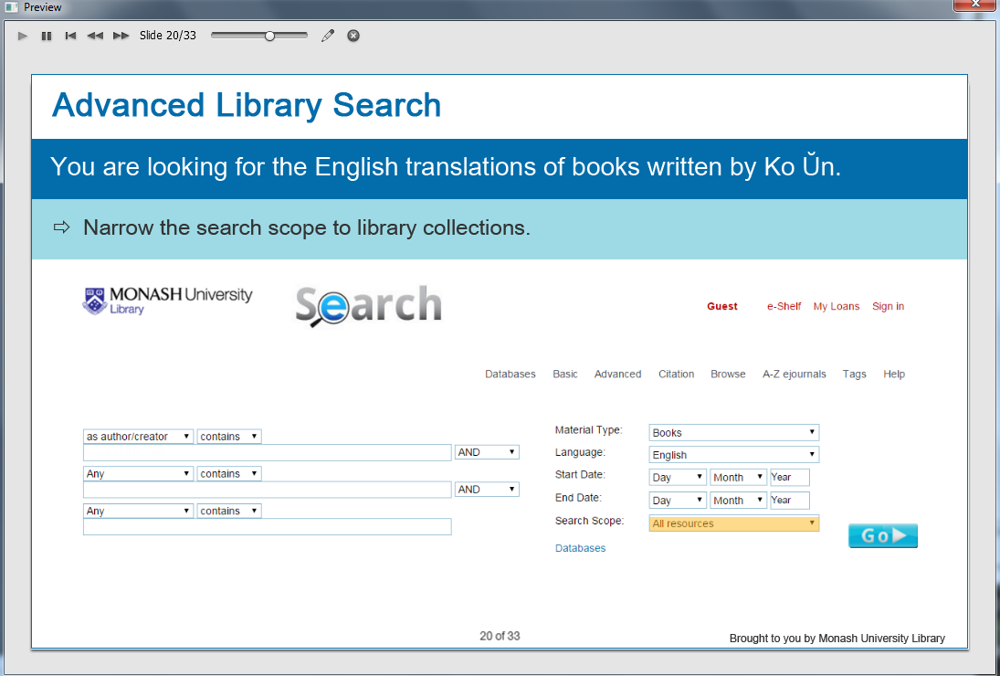

The “All resources” is highlighted.

Information caption:
Advanced Library Search.

Guide Me: You are looking for the English translations of works written by Ko Ŭn.

Instruction caption: Instruction caption: Narrow the search scope to library collections.
Click the highlighted field.

Screen Step 20: Choose “Library Collections” in Advanced Library Search by author

Image of Advanced Search by author screen.

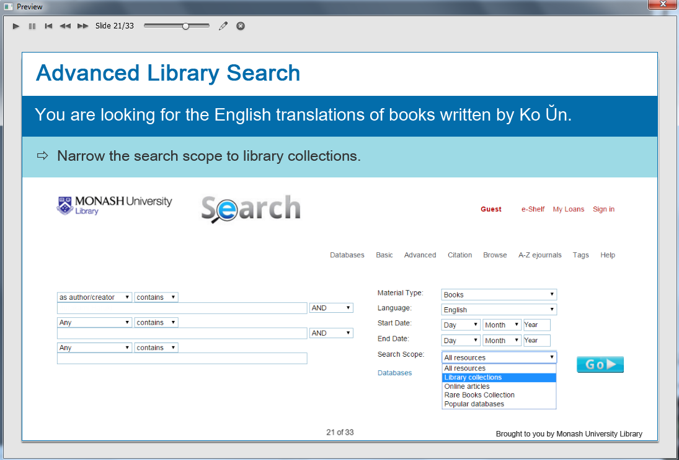

Information caption:
Advanced Library Search.

Guide Me: You are looking for the English translations of works written by Ko Ŭn.

Instruction caption: Instruction caption: Narrow the search scope to library collections.
Choose “Library collections”.

Screen Step 21: Enter your search term in Advanced Library Search by author

Image of Advanced Search by author screen.

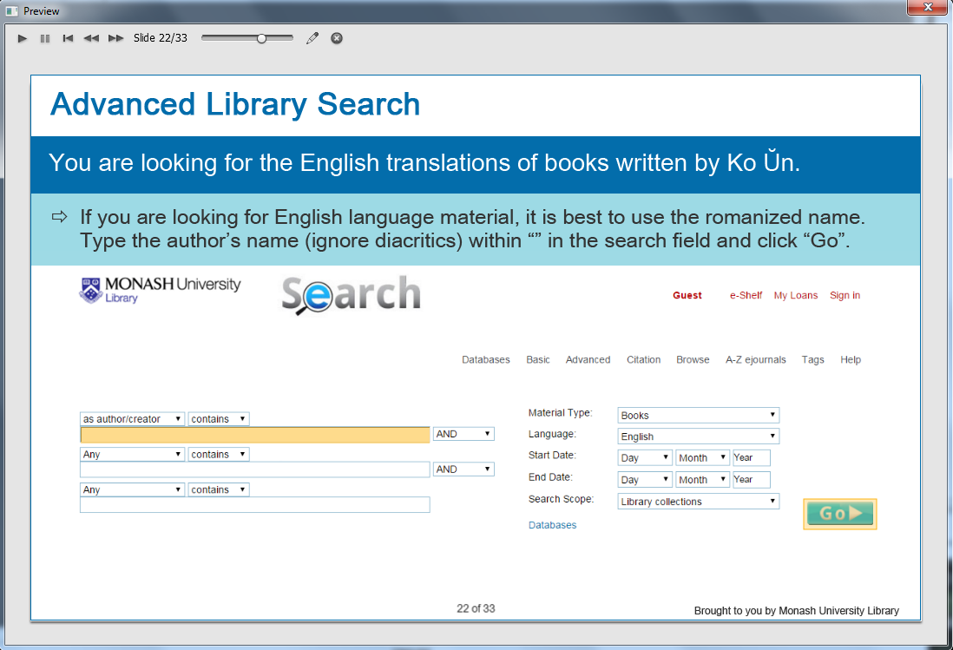

The search box is highlighted.

Information caption:
Advanced Library Search.

Guide Me: You are looking for the English translations of works written by Ko Ŭn.

Instruction caption: If you are looking for English language material, it is best to use the romanized name. Type the author’s name (ignore diacritics) within “” in the search field and click “Go”.

Feedback caption: Please type the author’s romanized name (ignore diacritics) within “” into the highlighted search box.

Screen Step 22: View your search results in Advanced Library Search by author

Image of the search results screen in Advanced Search by author.

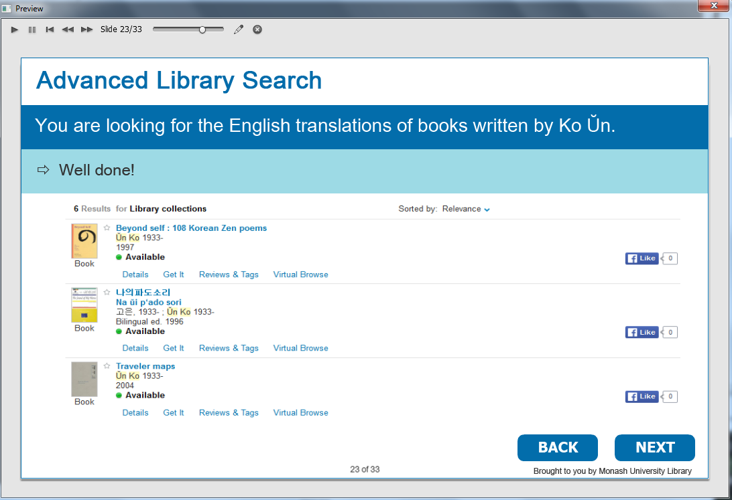

The total number of books found.

Information caption:
Advanced Library Search.

Guide Me: You are looking for the English translations of works written by Ko Ŭn.

Instruction caption: Well done!

Optional buttons: Click BACK or NEXT.

Screen Step 23: Advanced Library Search by subject

Image of Advanced Library Search by subject screen.

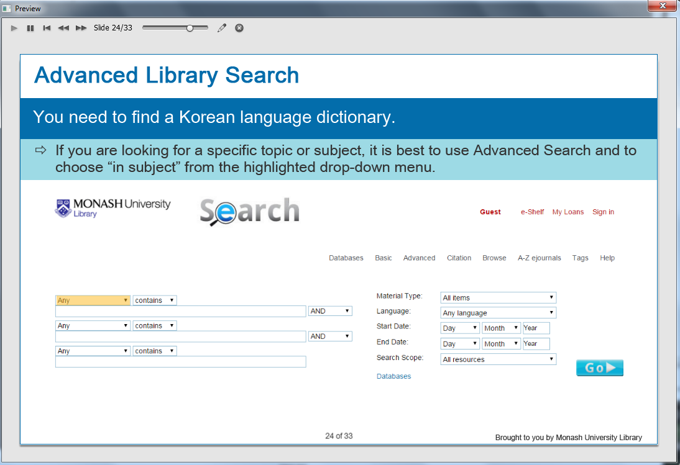

The “Any” is highlighted.

Information caption:
Advanced Library Search.

Guide Me: You need to find a Korean language dictionary.

Instruction caption: If you are looking for a specific topic or subject, it is best to use Advanced Search and to choose “in subject” from the highlighted drop-down menu.

Screen Step 24: Choose “in subject” in Advanced Library Search by subject

Image of Advanced Library Search by subject screen.

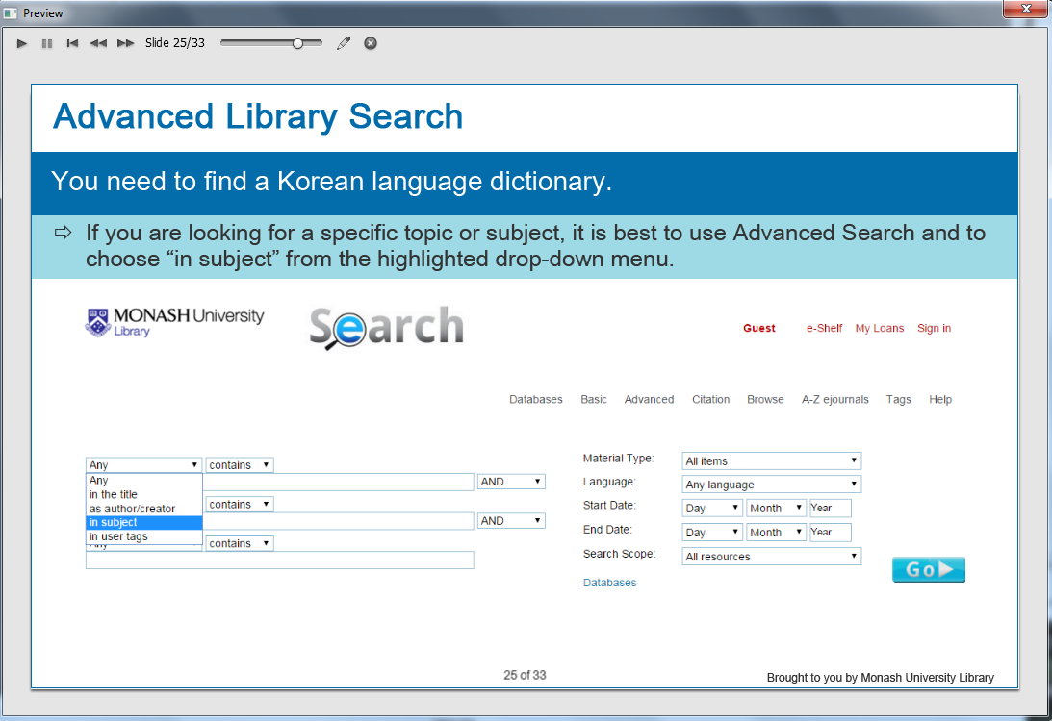

Information caption:
Advanced Library Search.

Guide Me: You need to find a Korean language dictionary.

Instruction caption: If you are looking for a specific topic or subject, it is best to use Advanced Search and to choose “in subject” from the highlighted drop-down menu.

Screen Step 25: Material type in Advanced Library Search by subject

Image of Advanced Library Search by subject screen.

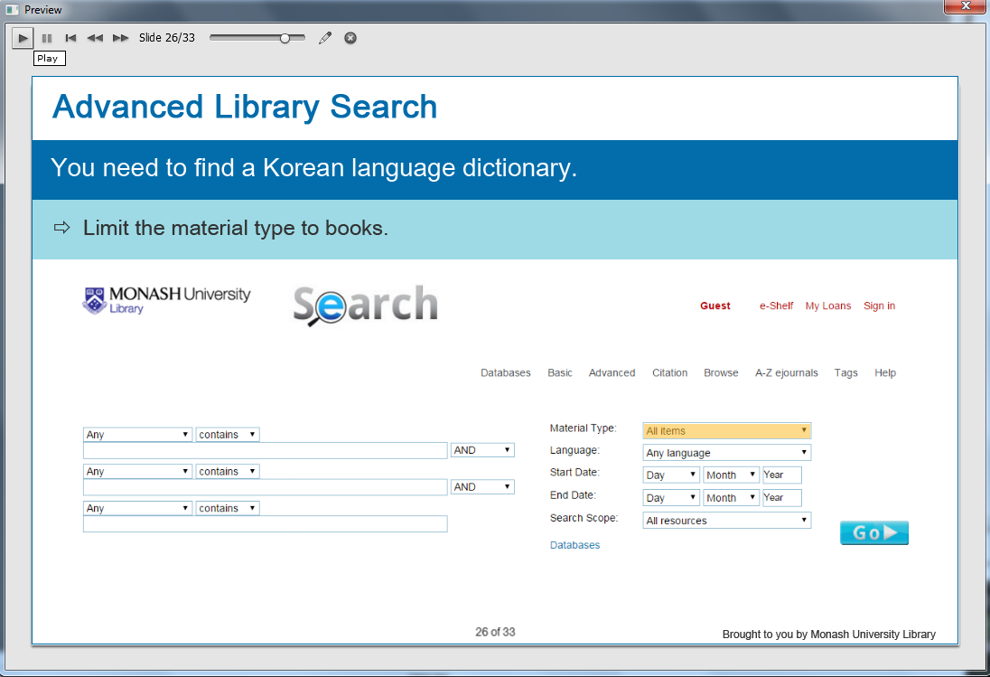

The “All items” is highlighted.

Information caption:
Advanced Library Search.

Guide Me: You need to find a Korean language dictionary.

Instruction caption: Limit the material type to books.
Click on the highlighted field.

Screen Step 26: Choose “Books” in Advanced Library Search by subject

Image of Advanced Library Search by subject screen.

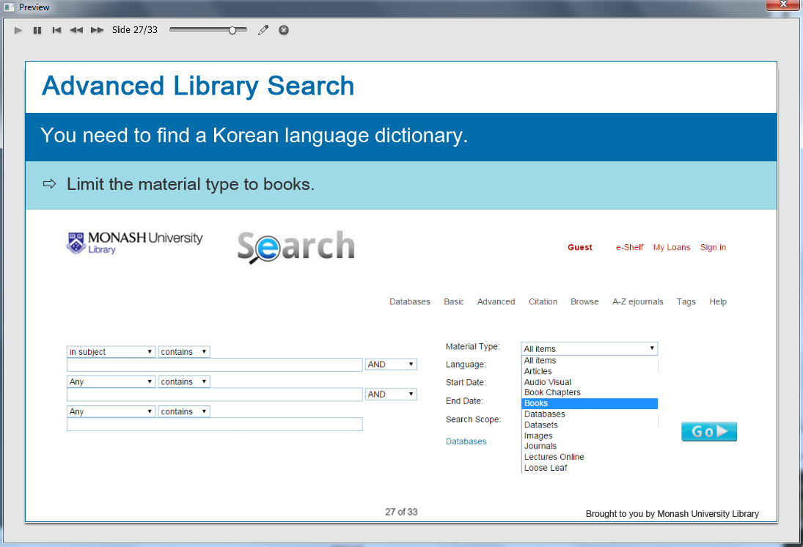

Information caption:
Advanced Library Search.

Guide Me: You need to find a Korean language dictionary.

Instruction caption: Limit the material type to books.
Choose “Books”.

Screen Step 27: Search scope in Advanced Library Search by subject

Image of Advanced Library Search by subject screen.

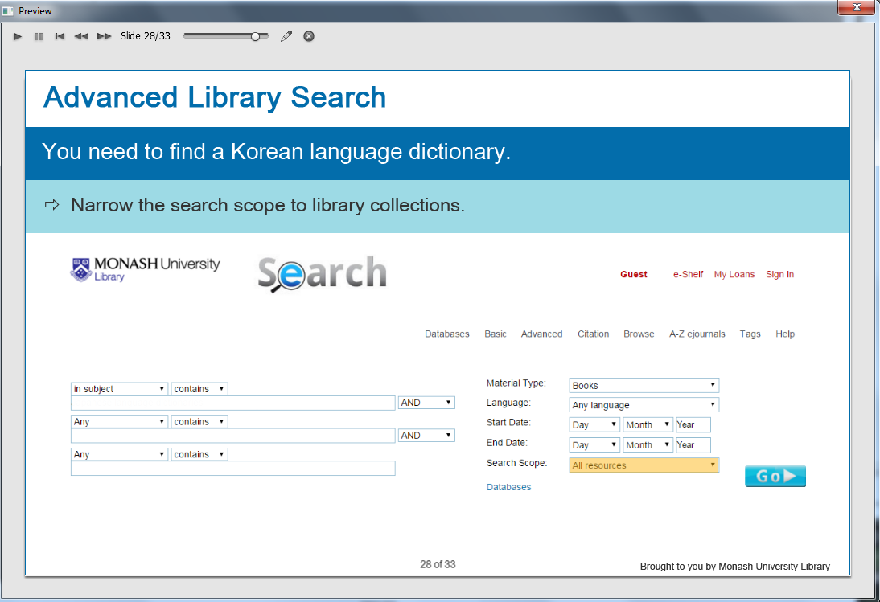

The “All resources” is highlighted.

Information caption:
Advanced Library Search.

Guide Me: You need to find a Korean language dictionary.

Instruction caption: Narrow the search scope to library collections.
Click on the highlighted field.

Screen Step 28: Choose “Library Collections” in Advanced Library Search by subject

Image of Advanced Library Search by subject screen.

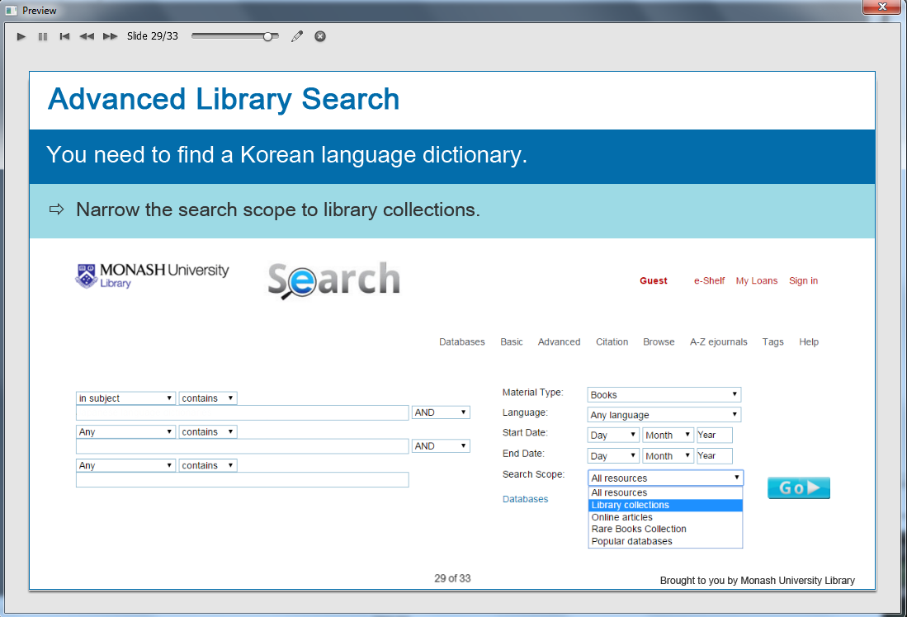

Information caption:
Advanced Library Search.

Guide Me: You need to find a Korean language dictionary.

Instruction caption: Narrow the search scope to library collections.
Choose “Library Collections”.

Screen Step 29: Enter your search term in Advanced Library Search by subject

Image of Advanced Library Search by subject screen.

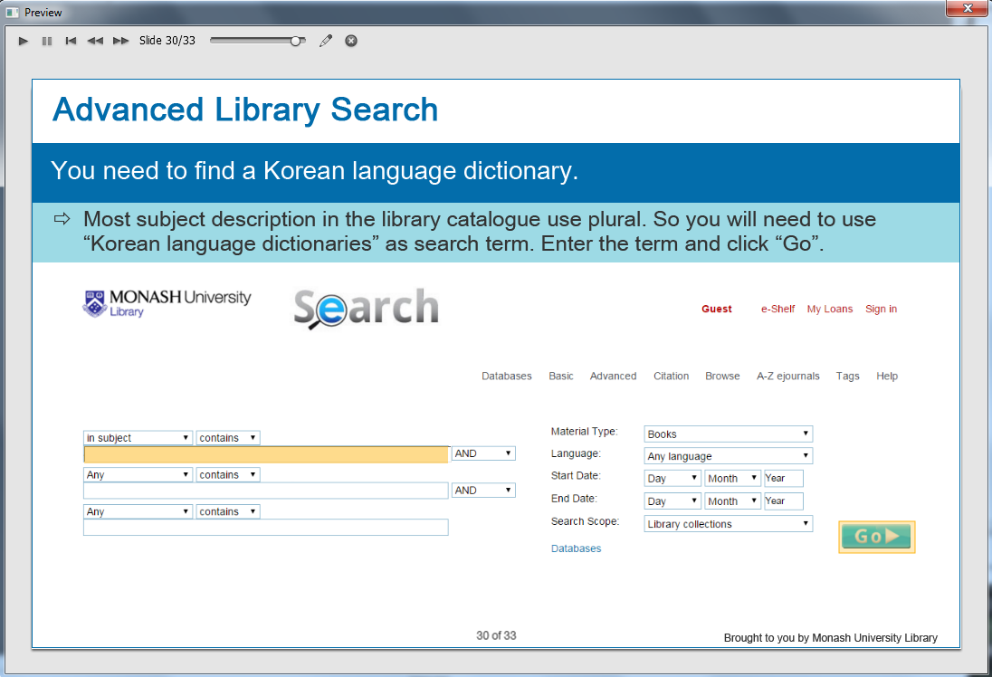

The search box is highlighted.

Information caption:
Advanced Library Search.

Guide Me: You need to find a Korean language dictionary.

Instruction caption: Most subject description in the library catalogue use plural. So you will need to use “Korean language dictionaries” as search term. Enter the term and click “Go”.

Screen Step 30: View your search results in Advanced Library Search by subject

Image of the search results screen in Advanced Library Search by subject.

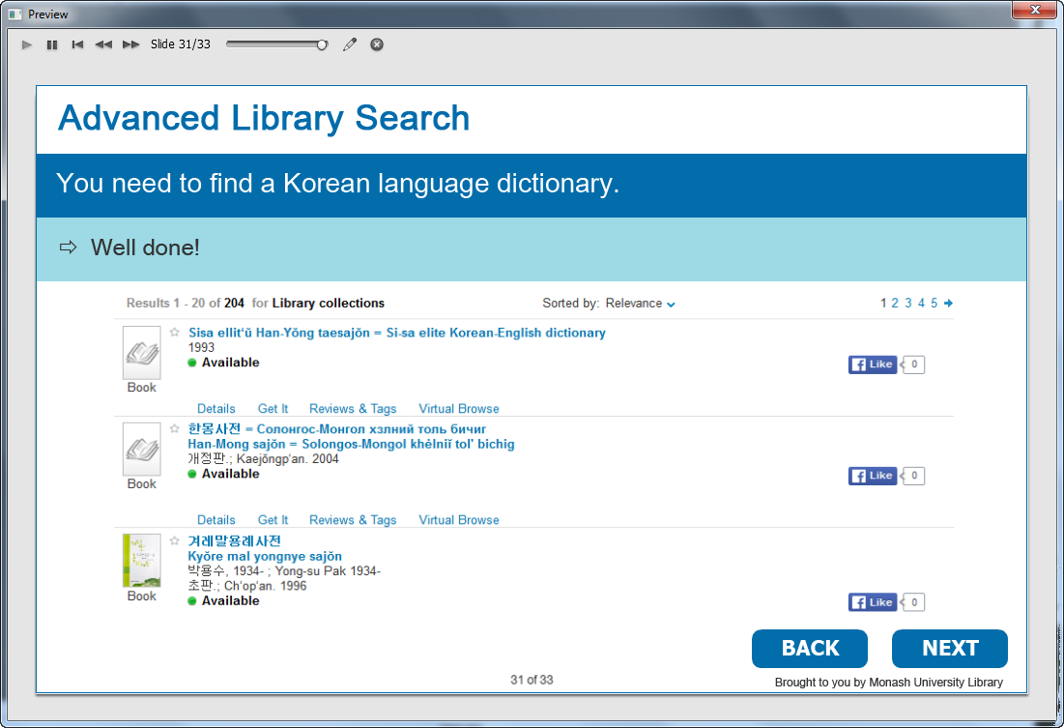

The total number of books found.

Information caption:
Advanced Library Search.

Guide Me: You need to find a Korean language dictionary.

Instruction caption: Well done!

Optional buttons: Click BACK or NEXT.

Screen Step 31: One last tip…

Image of tips screen.

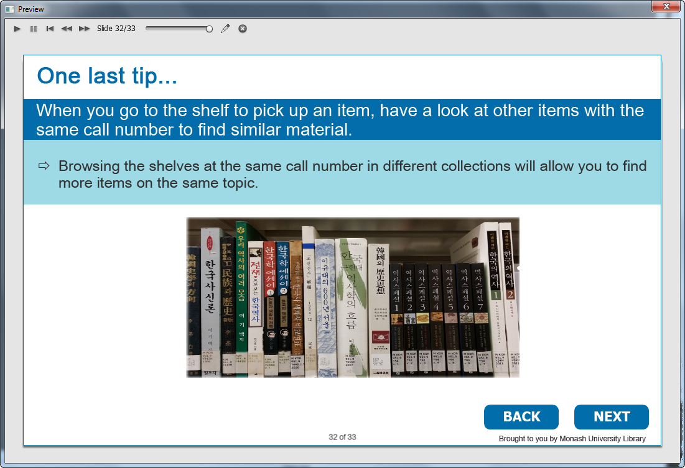

Information caption:
One last tip….

Guide Me: When you go to the shelf to pick up an item, have a look at other items with the same call number to find similar material.

Browsing the shelves at the same call number in different collections will allow you to find more items on the same topic.

Optional buttons: Click BACK or NEXT.

Screen Step 32: Summary of Korean resources in Library Search

Image of Summary screen.

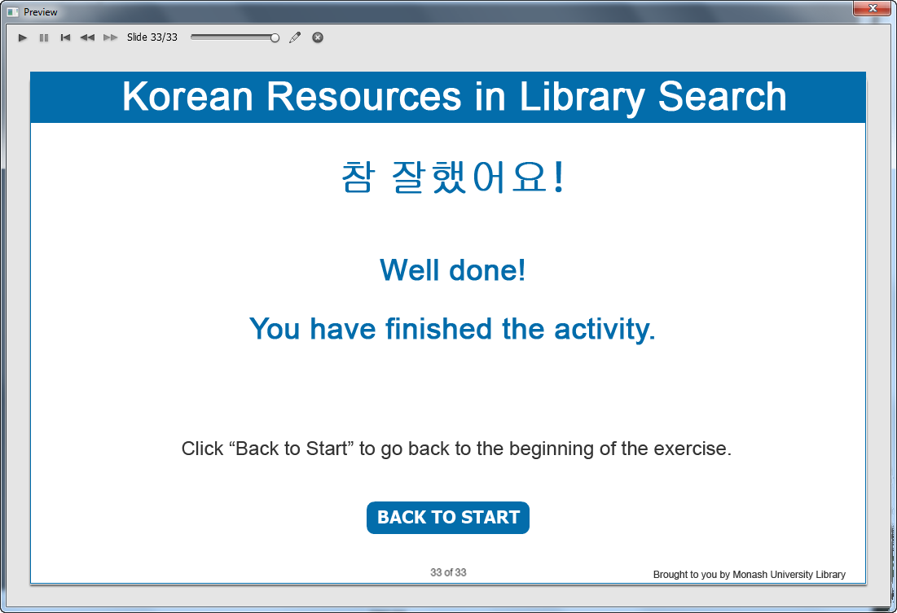

Information captions:
참 잘했어요 !
Well done!
You have finished the activity.

Instruction caption: Click “Back to Start” to go back to the beginning of the exercise.

