Captivate Simulations Storyboard

Guide Me Simulation

Input Methods for Korean

Image of title screen.

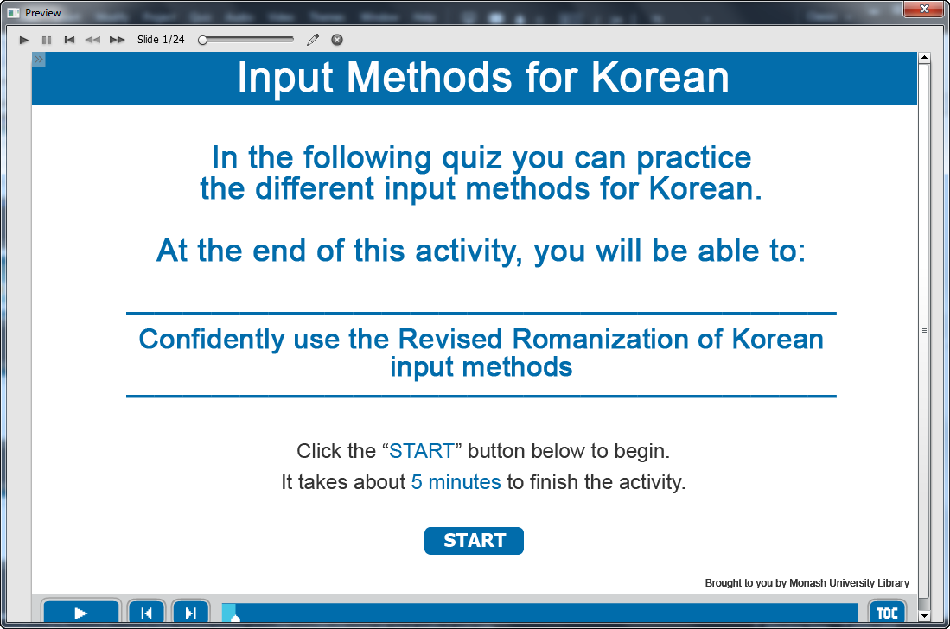

Information captions:
Input Methods for Korean.

Guide Me: In the following quiz you can practice the different input methods for Korean.
At the end of this activity, you will be able to:
Confidently use the Revised Romanization of Korean Romanization input methods to find Korean resources.

Instruction caption: Click the “START” button below to begin. It takes about 5 minutes to finish the activity.

Screen Step 1: Guide to take quiz of input methods for Korean

Image of the guide screen to take quiz.

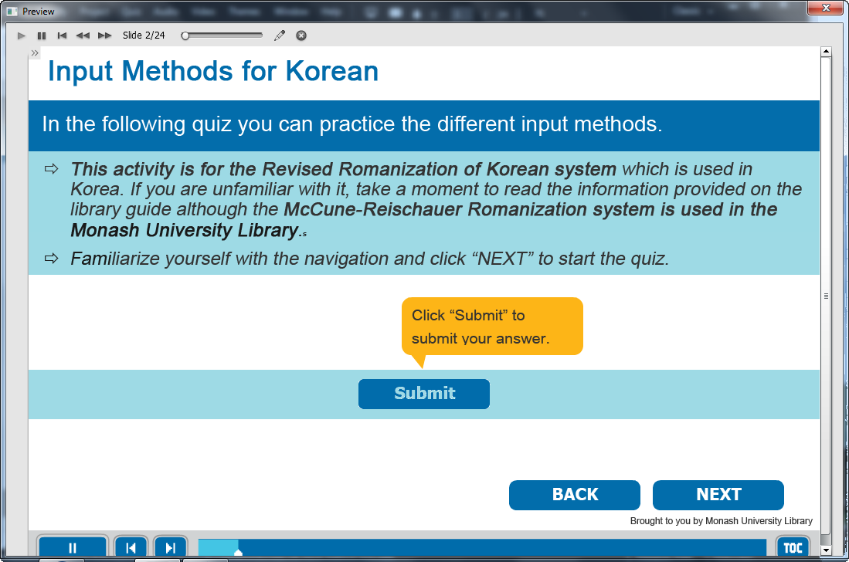

Information captions:
Input Methods for Korean.

Guide Me: This activity is for the Revised Romanization of Korean system which is used in Korea. If you are unfamiliar with it, take a moment to read the information provided on the library guide although the Revised Romanization of Korean system is used in the Monash University Library.
Familiarize yourself with the navigation and click “NEXT” to start the quiz.

Click “Submit” to submit your answer.

Instruction caption: Click BACK or NEXT.

Screen Step 2: Random quiz for input methods for Korean

Image of the quiz screen.

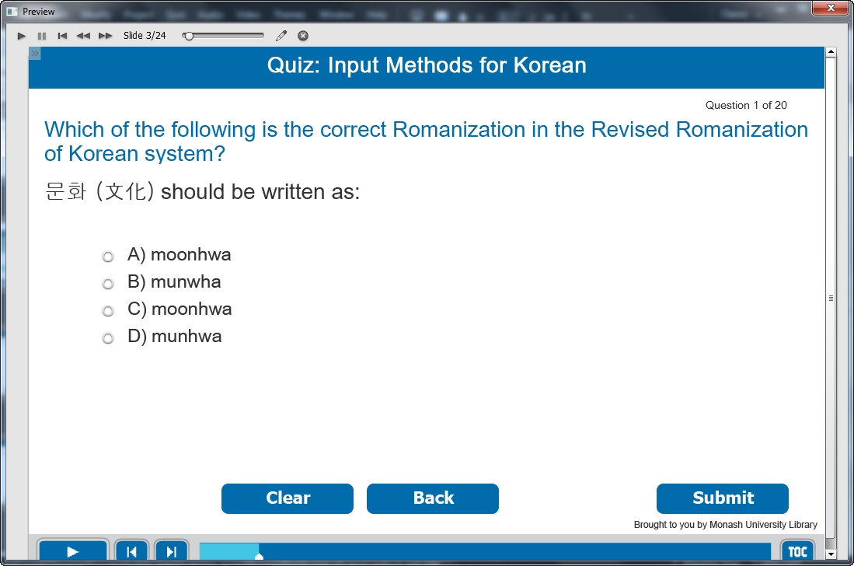

Information caption:
Quiz: Input Methods for Korean.

Guide Me: Which of the following is the correct Romanization in the Revised Romanization of Korean system?
문화 (文化) should be written as:

Instruction caption:
Select the correct answer from the multiple choice.

Feedback caption:
Please answer the question before continuing.
Correct - Click anywhere or press ‘y’ to continue.
Incorrect - The correct answer is munhwa. Click anywhere or press ‘y’ to continue.

Optional buttons: Click Clear or Back or Submit.

Screen Step 3: Random quiz for input methods for Korean

Image of the quiz screen.

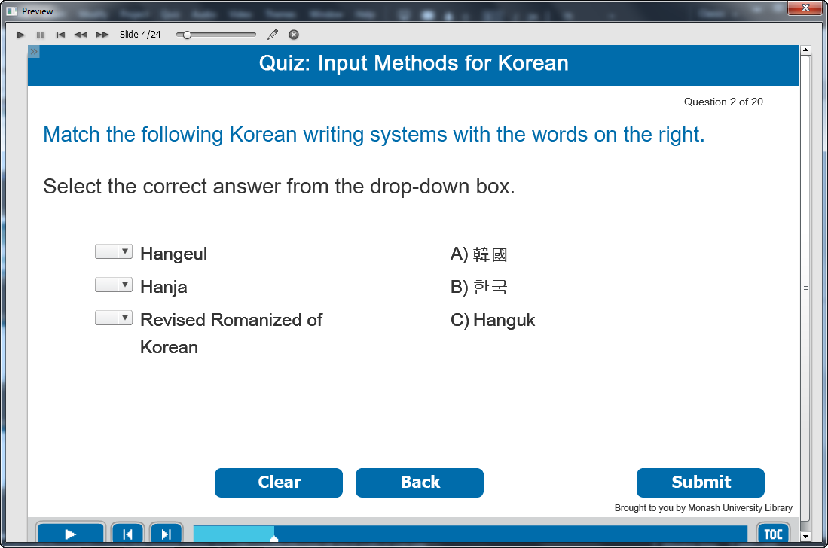

Information caption:
Quiz: Input Methods for Korean.

Guide Me: Match the following Korean writing systems with the words on the right.

Instruction caption: Select the correct answer from the drop-down box.

Feedback caption:
Please answer the question before continuing.
Correct - Click anywhere or press ‘y’ to continue.
Incorrect - The correct answer is Hangeul: 한국, Hanja: 韓國, Revised Romanization of Korean: Hanguk. Click anywhere or press ‘y’ to continue.

Optional buttons: Click Clear or Back or Submit.

Screen Step 4: Random quiz for input methods for Korean

Image of the quiz screen.

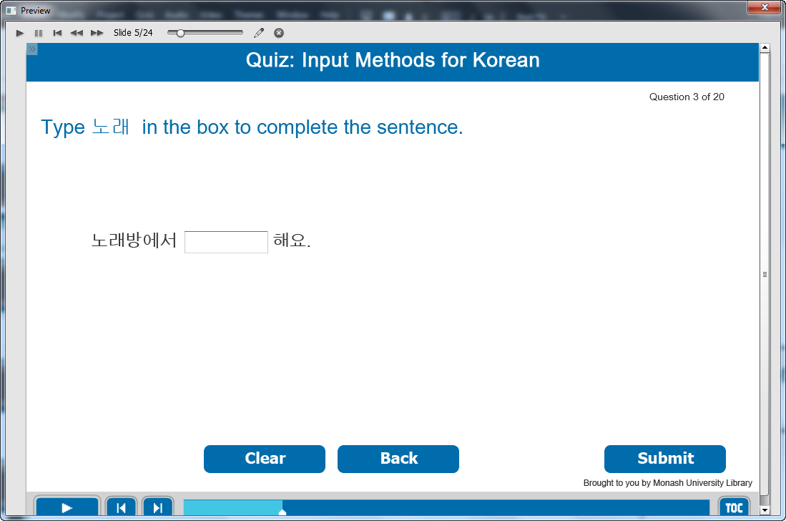

Information caption:
Quiz: Input Methods for Korean.

Guide Me: Type 노래 in the box to complete the sentence.

Instruction caption:
Type the correct answer in fill in the blank box.

Feedback caption:
Please answer the question before continuing.
Correct - Click anywhere or press ‘y’ to continue.
Incorrect - Use the IME to type in Hangeul for 노래. Click anywhere or press ‘y’ to continue.

Optional buttons: Click Clear or Back or Submit.

Screen Step 5: Random quiz for input methods for Korean

Image of the quiz screen.

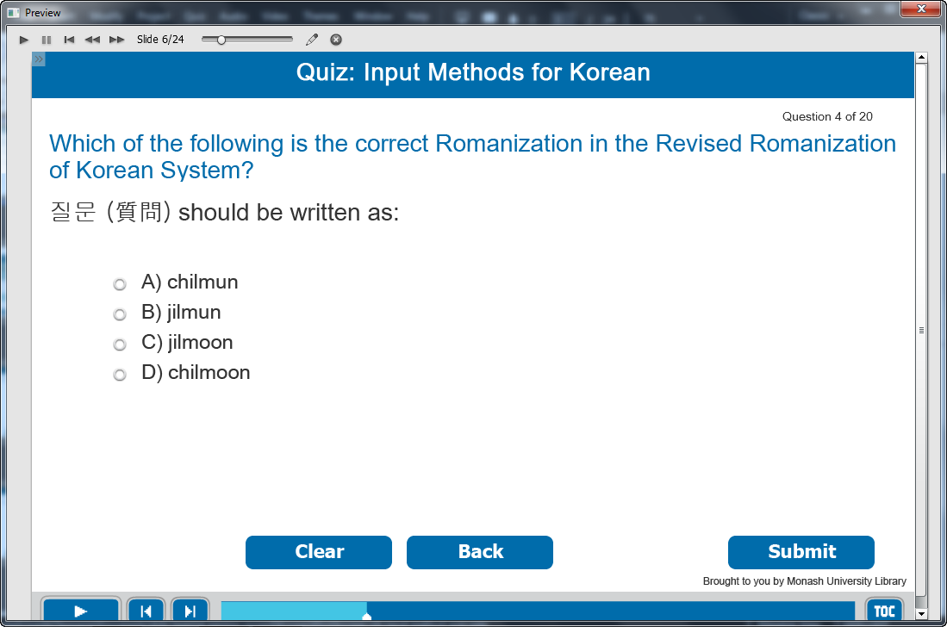

Information caption:
Quiz: Input Methods for Korean.

Guide Me: Which of the following is the correct Romanization in the Revised Romanization of Korean System?
질문 (質問) should be written as:

Instruction caption:
Select the correct answer from the multiple choice.

Feedback caption:
Please answer the question before continuing.
Correct - Click anywhere or press ‘y’ to continue.
Incorrect - The correct answer is jilmun. Click anywhere or press ‘y’ to continue.

Optional buttons: Click Clear or Back or Submit.

Screen Step 6: Random quiz for input methods for Korean

Image of the quiz screen.

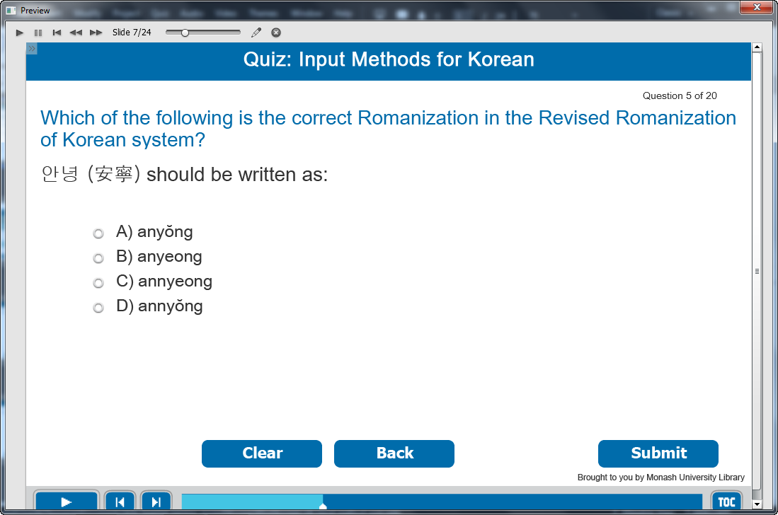

Information caption:
Quiz: Input Methods for Korean.

Guide Me: Which of the following is the correct Romanization in the Revised Romanization of Korean System?
안녕 (安寧) should be written as:

Instruction caption:
Select the correct answer from the multiple choice.

Feedback caption:
Please answer the question before continuing.
Correct - Click anywhere or press ‘y’ to continue.
Incorrect - The correct answer is annyeong. Click anywhere or press ‘y’ to continue.

Optional buttons: Click Clear or Back or Submit.

Screen Step 7: Random quiz for input methods for Korean

Image of the quiz screen.

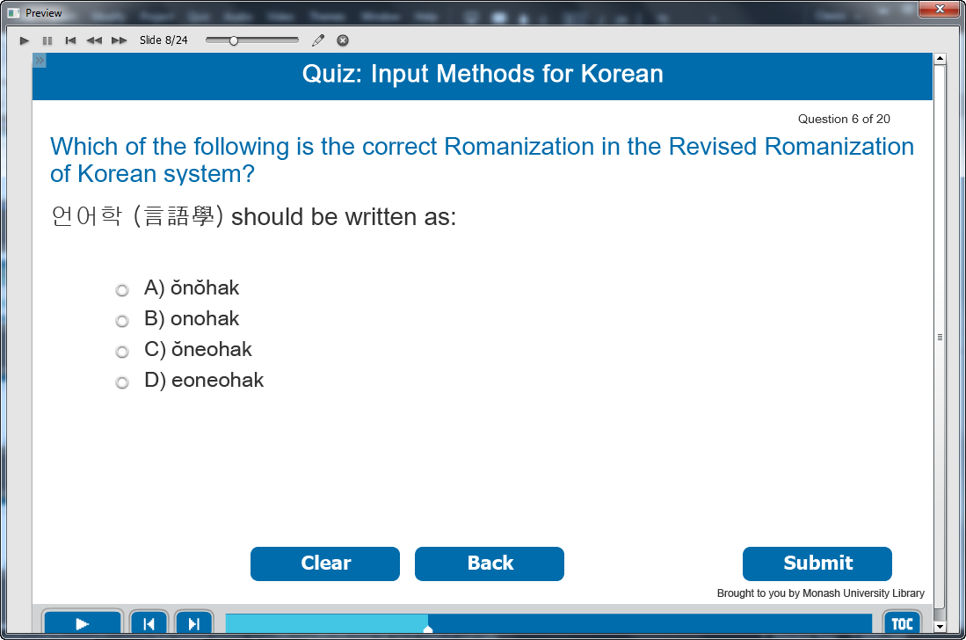

Information caption:
Quiz: Input Methods for Korean.

Guide Me: Which of the following is the correct Romanization in the Revised Romanization of Korean System?
언어학 (言語學) should be written as:

Instruction caption:
Select the correct answer from the multiple choice.

Feedback caption:
Please answer the question before continuing.
Correct - Click anywhere or press ‘y’ to continue.
Incorrect - The correct answer is eoneohak. Click anywhere or press ‘y’ to continue.

Optional buttons: Click Clear or Back or Submit.

Screen Step 8: Random quiz for input methods for Korean

Image of the quiz screen.

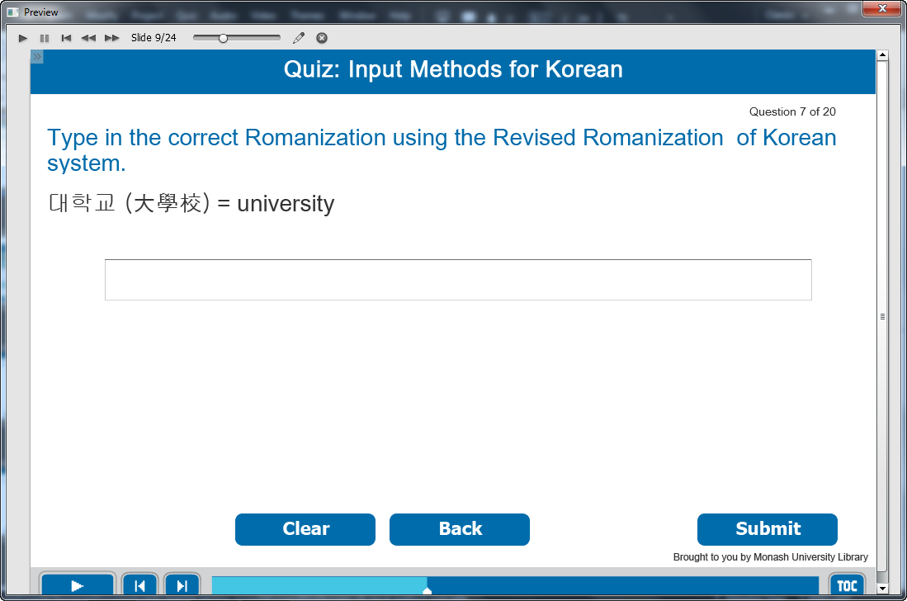

Information caption:
Quiz: Input Methods for Korean.

Guide Me: Type in the correct Romanization using the Revised Romanization of Korean system.
대학교 (大學校) = university

Instruction caption:
Fill the correct answer in the box.

Feedback caption:
Please answer the question before continuing.
Correct - Click anywhere or press ‘y’ to continue.
Incorrect - The correct answer is daehakgyo. Click anywhere or press ‘y’ to continue.

Optional buttons: Click Clear or Back or Submit.

Screen Step 9: Random quiz for input methods for Korean

Image of the quiz screen.

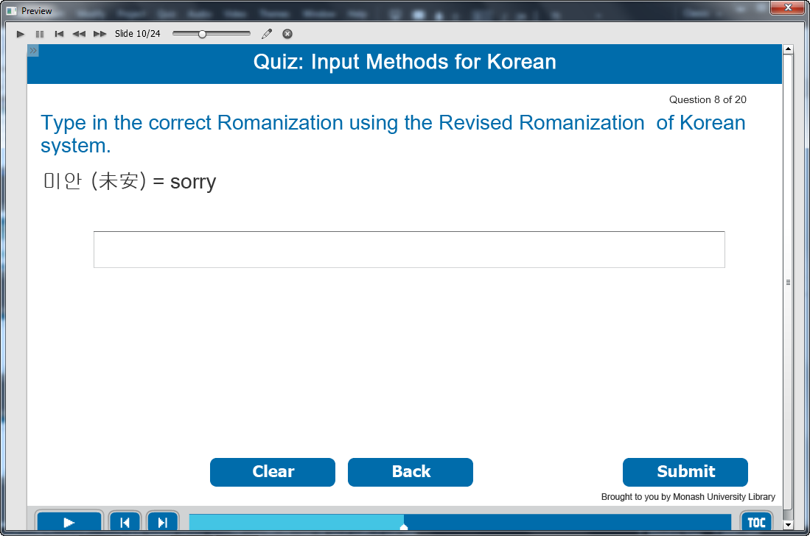

Information caption:
Quiz: Input Methods for Korean.

Guide Me: Type in the correct Romanization using the Revised Romanization of Korean system.
미안 (未安) = sorry

Instruction caption:
Fill the correct answer in the box.

Feedback caption:
Please answer the question before continuing.
Correct - Click anywhere or press ‘y’ to continue.
Incorrect - The correct answer is mian. Click anywhere or press ‘y’ to continue.

Optional buttons: Click Clear or Back or Submit.

Screen Step 10: Random quiz for input methods for Korean

Image of the quiz screen.

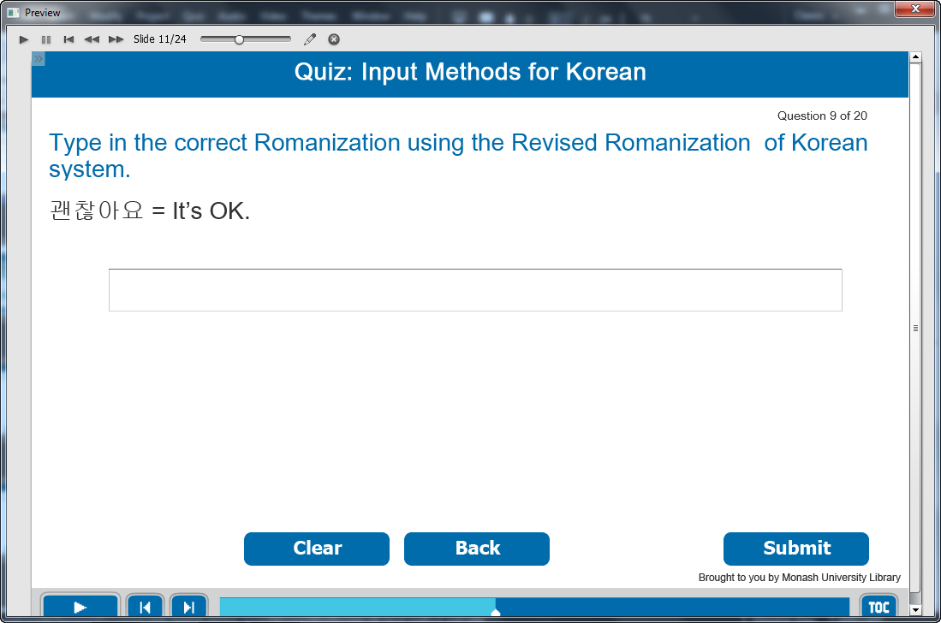

Information caption:
Quiz: Input Methods for Korean.

Guide Me: Type in the correct Romanization using the Revised Romanization of Korean system.
괜찮아요 = It’s OK.

Instruction caption:
Fill the correct answer in the box.

Feedback caption:
Please answer the question before continuing.
Correct - Click anywhere or press ‘y’ to continue.
Incorrect - The correct answer is gwaenchanayo. Click anywhere or press ‘y’ to continue.

Optional buttons: Click Clear or Back or Submit.

Screen Step 11: Random quiz for input methods for Korean

Image of the quiz screen.

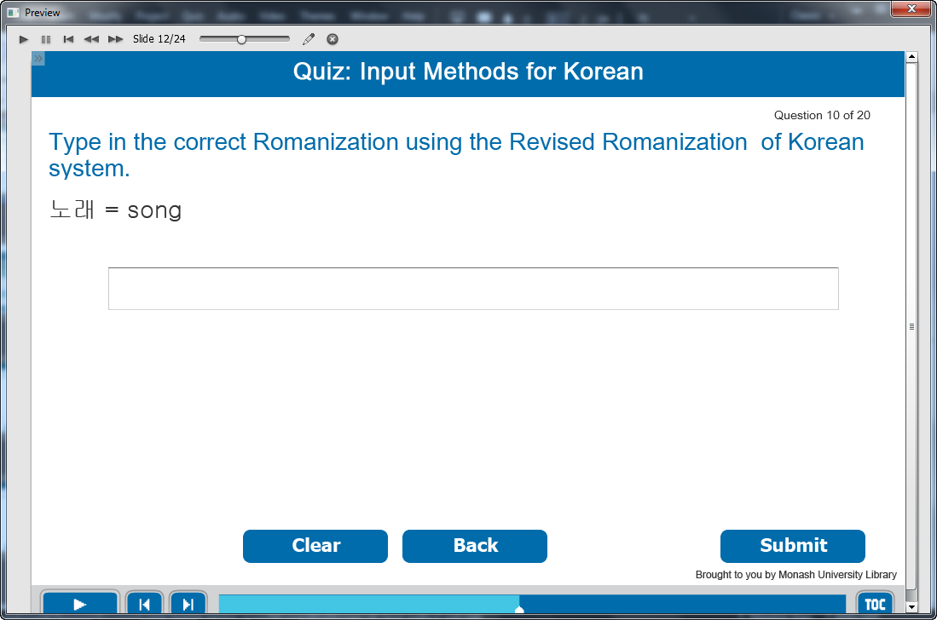

Information caption:
Quiz: Input Methods for Korean.

Guide Me: Type in the correct Romanization using the Revised Romanization of Korean system.
노래 = song.

Instruction caption:
Fill the correct answer in the box.

Feedback caption:
Please answer the question before continuing.
Correct - Click anywhere or press ‘y’ to continue.
Incorrect - The correct answer is norae. Click anywhere or press ‘y’ to continue.

Optional buttons: Click Clear or Back or Submit.

Screen Step 12: Random quiz for input methods for Korean

Image of the quiz screen.

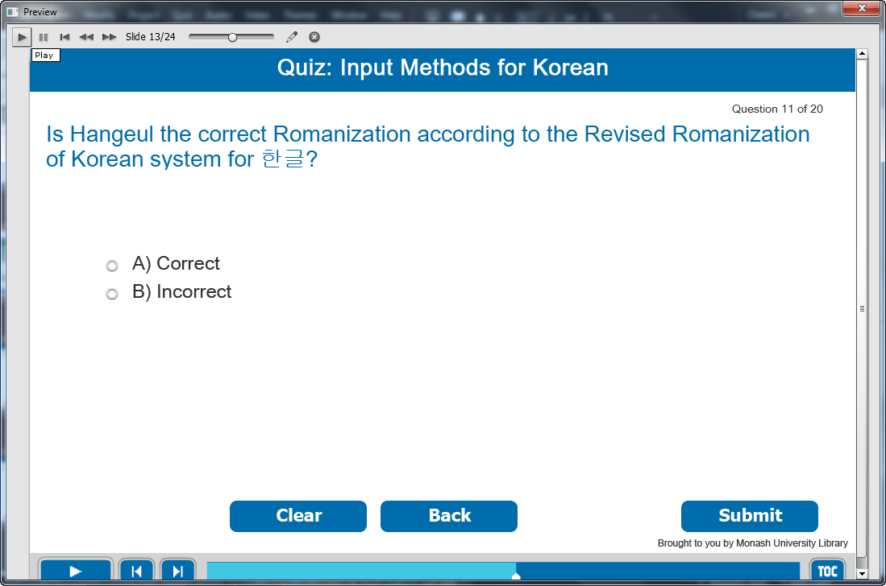

Information caption:
Quiz: Input Methods for Korean.

Guide Me: Is Han’gŭl the correct Romanization according to the Revised Romanization of Korean system for 한글?

Instruction caption:
Select the correct answer from the multiple choice.

Feedback caption:
Please answer the question before continuing.
Correct - Click anywhere or press ‘y’ to continue.
Incorrect - Hangeul is the correct RRK Romanization for 한글. Click anywhere or press ‘y’ to continue.

Optional buttons: Click Clear or Back or Submit.

Screen Step 13: Random quiz for input methods for Korean

Image of the quiz screen.

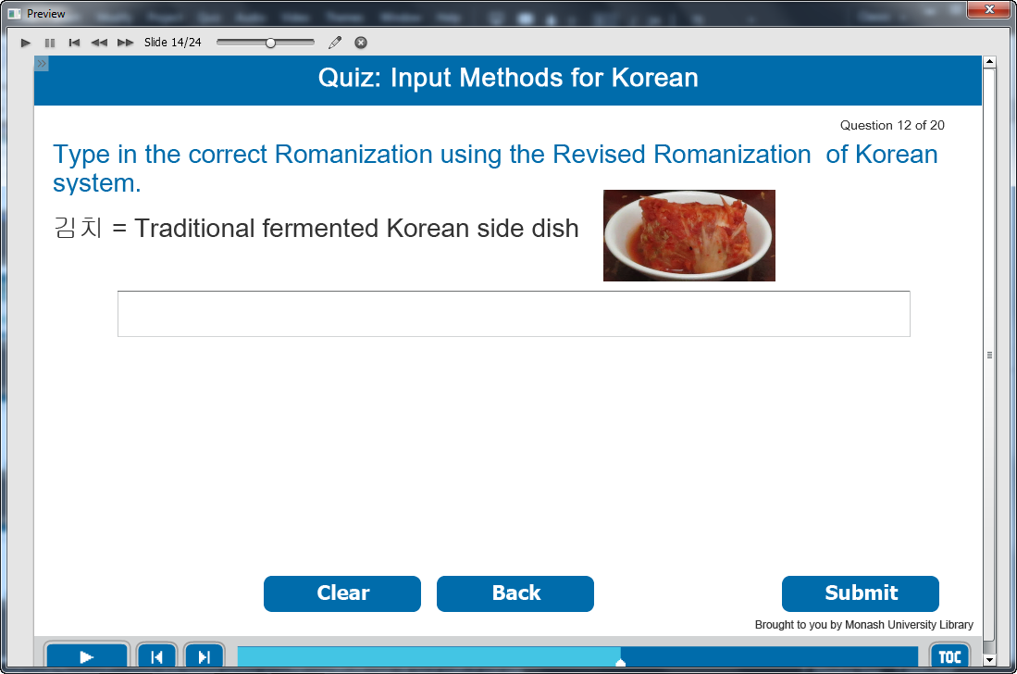

Information caption:
Quiz: Input Methods for Korean.

Guide Me: Type in the correct Romanization using the Revised Romanization of Korean system.
김치 = Traditional fermented Korean side dish

Instruction caption:
Fill the correct answer in the box.

Feedback caption:
Please answer the question before continuing.
Correct - Click anywhere or press ‘y’ to continue.
Incorrect - The correct answer is Kimchi. Click anywhere or press ‘y’ to continue.

Optional buttons: Click Clear or Back or Submit.

Screen Step 14: Random quiz for input methods for Korean

Image of the quiz screen.

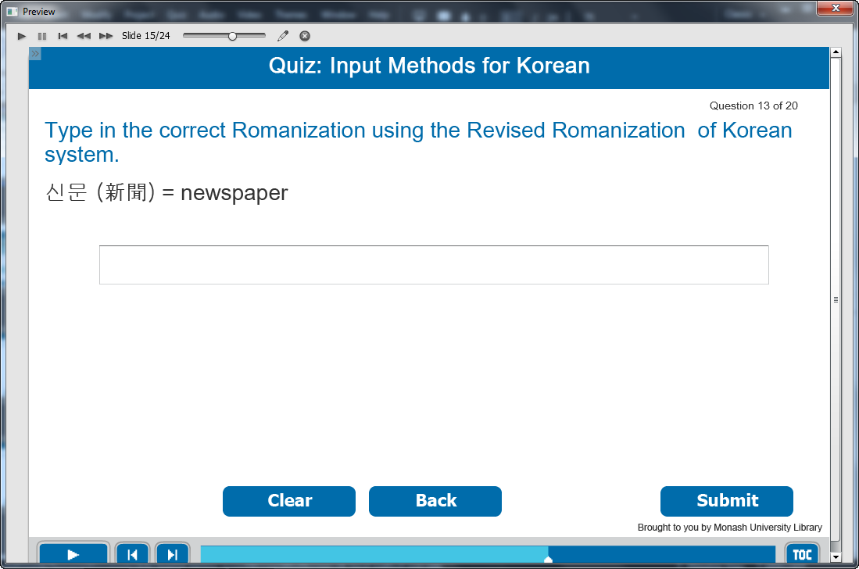

Information caption:
Quiz: Input Methods for Korean.

Guide Me: Type in the correct Romanization using the Revised Romanization of Korean system.
신문 (新聞) = newspaper

Instruction caption:
Fill the correct answer in the box.

Feedback caption:
Please answer the question before continuing.
Correct - Click anywhere or press ‘y’ to continue.
Incorrect - The correct answer is sinmun. Click anywhere or press ‘y’ to continue.

Optional buttons: Click Clear or Back or Submit.

Screen Step 15: Random quiz for input methods for Korean

Image of the quiz screen.

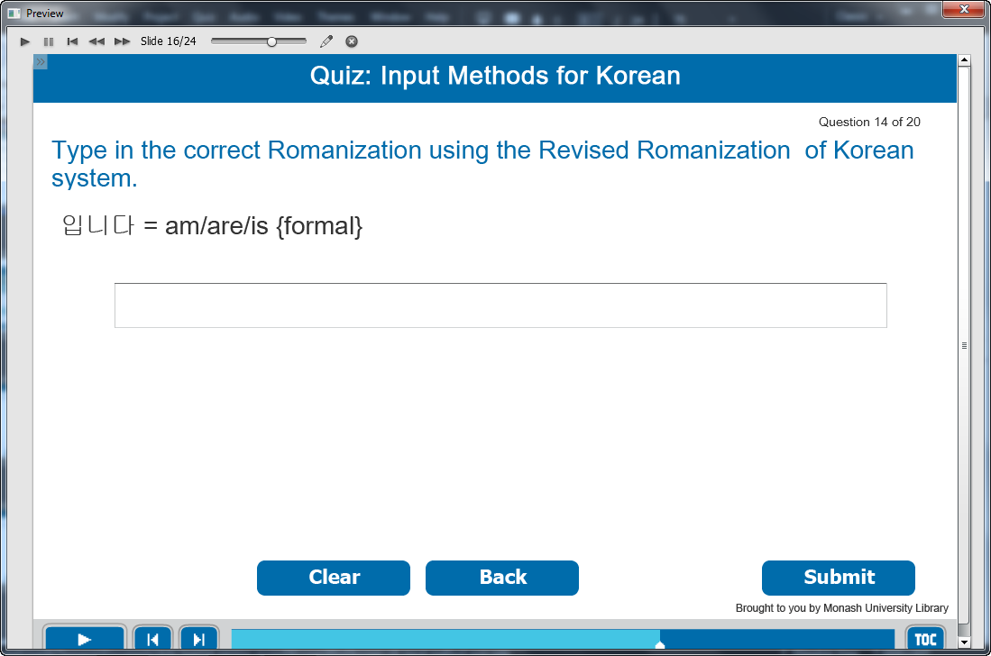

Information caption:
Quiz: Input Methods for Korean.

Guide Me: Type in the correct Romanization using the Revised Romanization of Korean system.
입니다 = am/are/is {formal}

Instruction caption:
Fill the correct answer in the box.

Feedback caption:
Please answer the question before continuing.
Correct - Click anywhere or press ‘y’ to continue.
Incorrect - The correct answer is imnida. Click anywhere or press ‘y’ to continue.

Optional buttons: Click Clear or Back or Submit.

Screen Step 16: Random quiz for input methods for Korean

Image of the quiz screen.

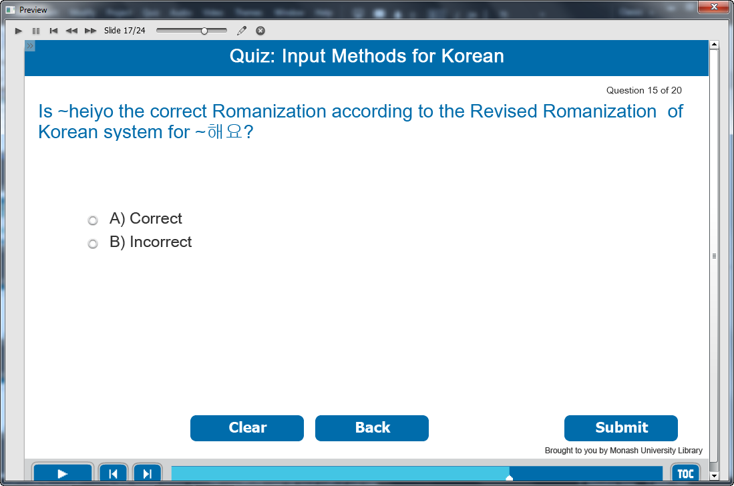

Information caption:
Quiz: Input Methods for Korean.

Guide Me: Is ~heiyo the correct Romanization according to the Revised Romanization of Korean system for ~해요?

Instruction caption:
Select the correct answer from the multiple choice.

Feedback caption:
Please answer the question before continuing.
Correct - The correct Romanization for ~해요 is ~haeyo. Click anywhere or press ‘y’ to continue..
Incorrect - ~haeyo is the correct Romanization for ~해요. Click anywhere or press ‘y’ to continue.

Optional buttons: Click Clear or Back or Submit.

Screen Step 17: Random quiz for input methods for Korean

Image of the quiz screen.

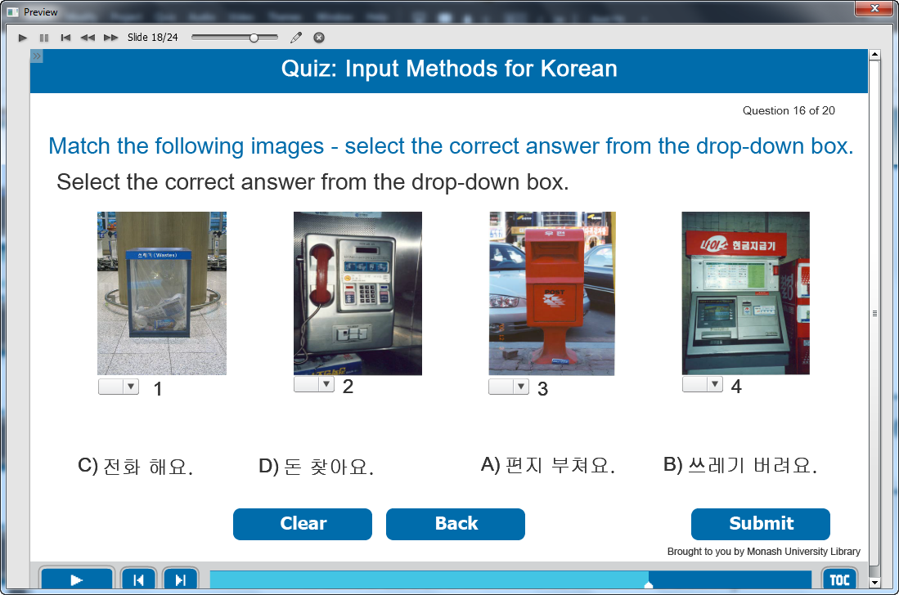

Information caption:
Quiz: Input Methods for Korean.

Guide Me: Match the following Korean writing systems with the words on the right.

Instruction caption: Select the correct answer from the drop-down box.

Feedback caption:
Please answer the question before continuing.
Correct - Click anywhere or press ‘y’ to continue.
Incorrect - The correct answer is 1: 쓰레기 버려요, 2: 전화해요, 3: 편지 부쳐요, 4: 돈 찾아요. Click anywhere or press ‘y’ to continue.

Optional buttons: Click Clear or Back or Submit.

Screen Step 18: Random quiz for input methods for Korean

Image of the quiz screen.

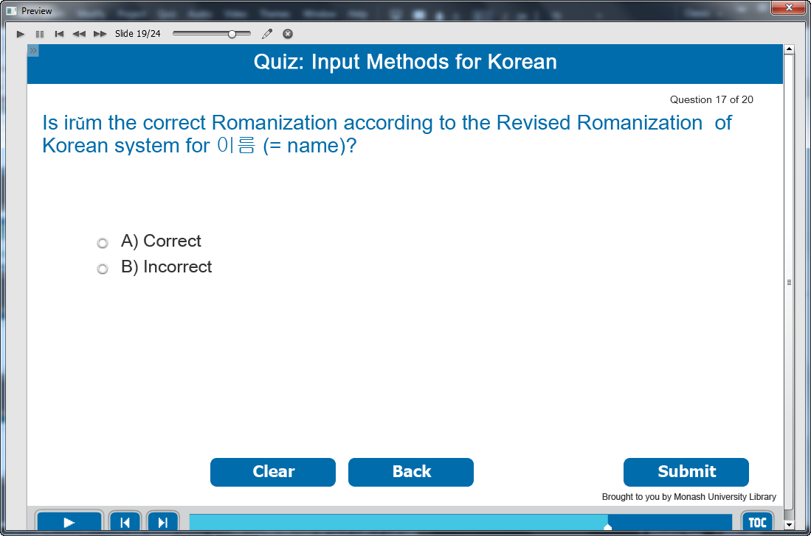

Information caption:
Quiz: Input Methods for Korean.

Guide Me: Is irŭm the correct Romanization according to the Revised Romanization of Korean system for 이름 (= name)?

Instruction caption:
Select the correct answer from the multiple choice.

Feedback caption:
Please answer the question before continuing.
Correct - The correct Revised Romanization of Korean for 이름 (= name) is ireum..Click anywhere or press ‘y’ to continue.
Incorrect - The correct Revised Romanization of Korean for 이름 (= name) is ireum. Click anywhere or press ‘y’ to continue.

Optional buttons: Click Clear or Back or Submit.

Screen Step 19: Random quiz for input methods for Korean

Image of the quiz screen.

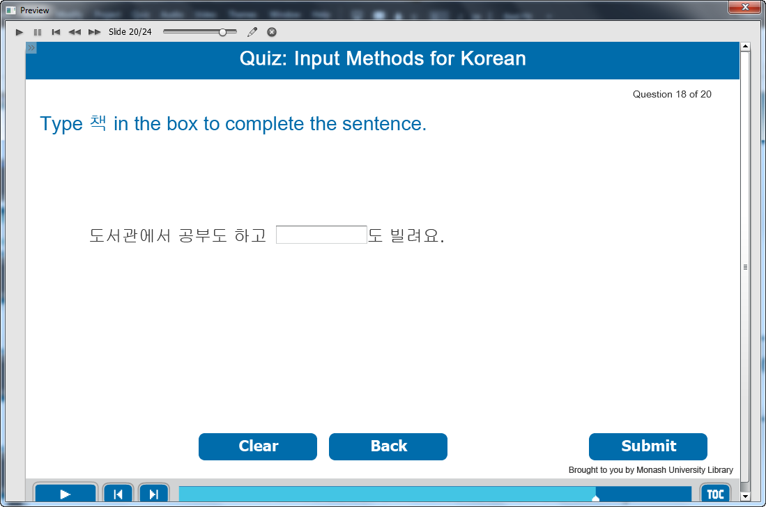

Information caption:
Quiz: Input Methods for Korean.

Guide Me: Type 책 in the box to complete the sentence.

Instruction caption:
Type the correct answer in fill in the blank box.

Feedback caption:
Please answer the question before continuing.
Correct - Click anywhere or press ‘y’ to continue.
Incorrect - The correct answer is 책. Click anywhere or press ‘y’ to continue.

Optional buttons: Click Clear or Back or Submit.

Screen Step 20: Random quiz for input methods for Korean

Image of the quiz screen.

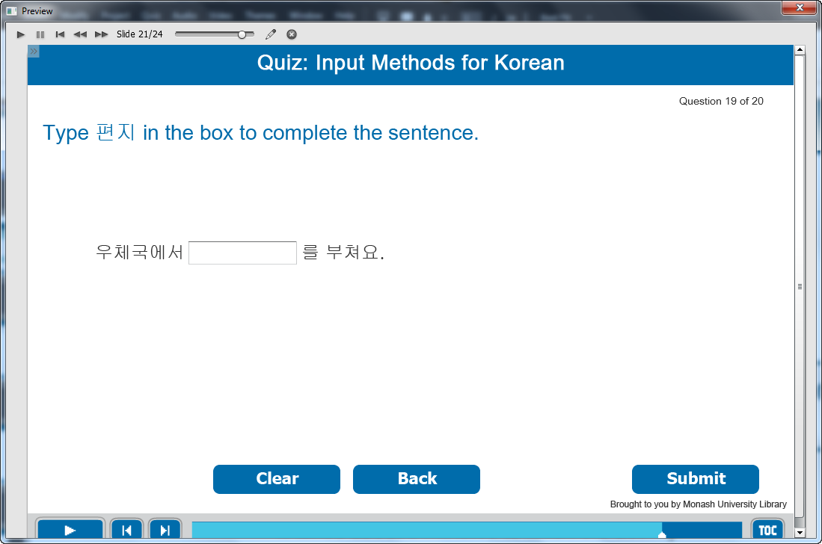

Information caption:
Quiz: Input Methods for Korean.

Guide Me: Type 편지 in the box to complete the sentence.

Instruction caption:
Type the correct answer in fill in the blank box.

Feedback caption:
Please answer the question before continuing.
Correct - Click anywhere or press ‘y’ to continue.
Incorrect - The correct answer is 편지. Click anywhere or press ‘y’ to continue.

Optional buttons: Click Clear or Back or Submit.

Screen Step 21: Random quiz for input methods for Korean

Image of the quiz screen.

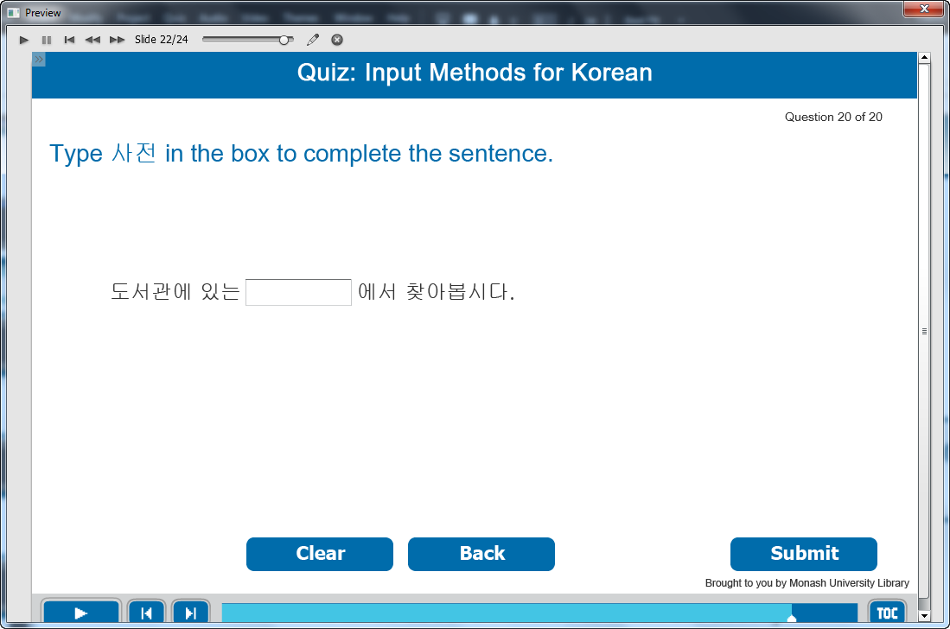

Information caption:
Quiz: Input Methods for Korean.

Guide Me: Type 사전 in the box to complete the sentence.

Instruction caption:
Type the correct answer in fill in the blank box.

Feedback caption:
Please answer the question before continuing.
Correct - Click anywhere or press ‘y’ to continue.
Incorrect - The correct answer is 사전. Click anywhere or press ‘y’ to continue.

Optional buttons: Click Clear or Back or Submit.

Screen Step 22: Well done!

Image of Well done screen.

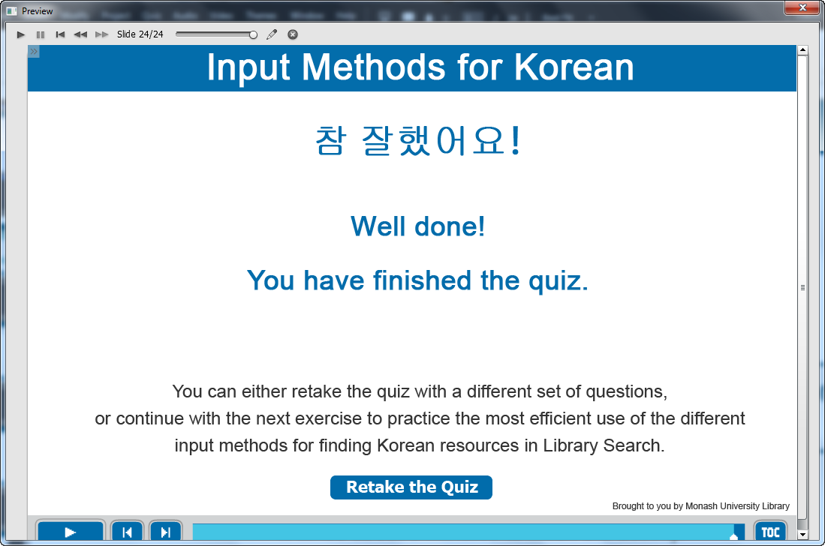

Information captions:
Input Methods for Korean.
참 잘했어요!
Well done!
You have finished the quiz.
You can either retake the quiz with a different set of questions, or continue with the next exercise to practice the most efficient use of the different input methods for finding Korean resources in Library Search.

Instruction caption: Click “Retake the Quiz” to go back to the beginning of the quiz.

