Captivate Simulations Storyboard

Guide Me Simulation

Input Methods for Korean

Image of title screen.

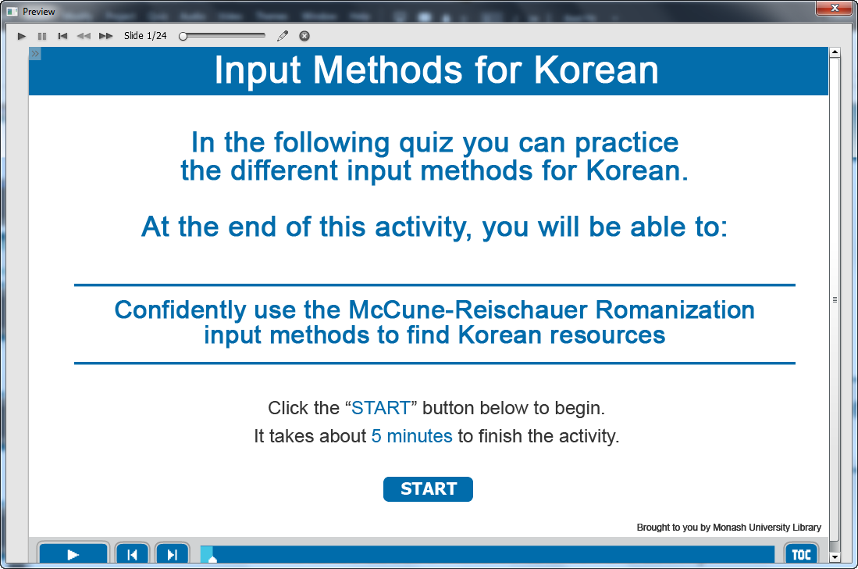

Information captions:
Input Methods for Korean.

Guide Me: In the following quiz you can practice the different input methods for Korean.
At the end of this activity, you will be able to:
Confidently use the McCune-Reischauer Romanization input methods to find Korean resources.

Instruction caption: Click the “START” button below to begin. It takes about 5 minutes to finish the activity.

Screen Step 1: Guide to take quiz of input methods for Korean

Image of the guide screen to take quiz.

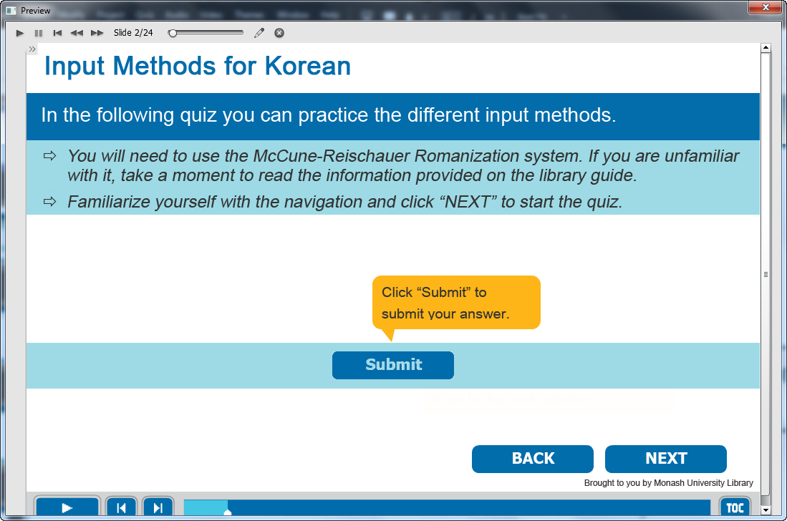

Information captions:
Input Methods for Korean.

Guide Me: In the following quiz you can practice the different input methods.
You will need to use the McCune-Reischauer Romanization system. If you are unfamiliar with it, take a moment to read the information provided on the library guide.
Familiarize yourself with the navigation and click “NEXT” to start the quiz.
Click “Submit” to submit your answer.

Instruction caption: Click BACK or NEXT.

Screen Step 2: Random quiz for input methods for Korean

Image of the quiz screen.

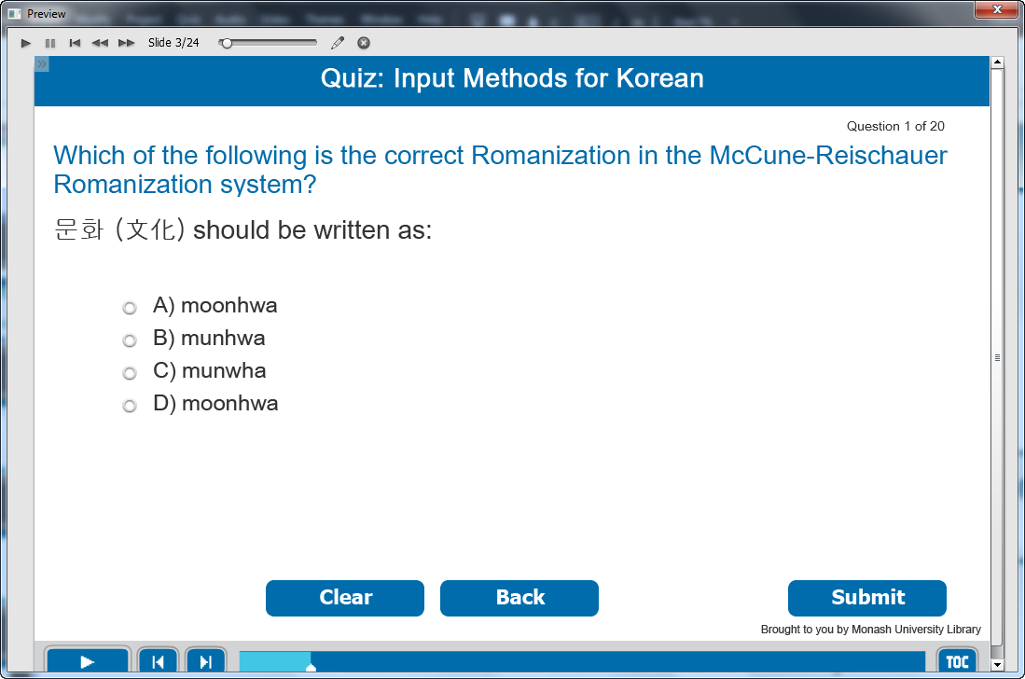

Information caption:
Quiz: Input Methods for Korean.

Guide Me: Which of the following is the correct Romanization in the McCune-Reischauer Romanization system?
문화 (文化) should be written as:

Instruction caption:
Select the correct answer from the multiple choice.

Feedback caption:
Please answer the question before continuing.
Correct - Click anywhere or press ‘y’ to continue.
Incorrect - The correct answer is munhwa. Click anywhere or press ‘y’ to continue.

Optional buttons: Click Clear or Back or Submit.

Screen Step 3: Random quiz for input methods for Korean

Image of the quiz screen.

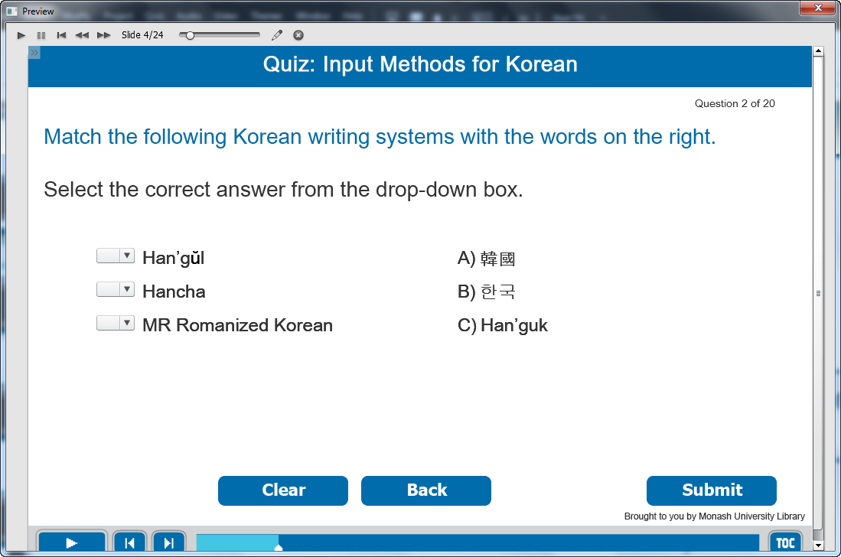

Information caption:
Quiz: Input Methods for Korean.

Guide Me: Match the following Korean writing systems with the words on the right.

Instruction caption: Select the correct answer from the drop-down box.

Feedback caption:
Please answer the question before continuing.
Correct - Click anywhere or press ‘y’ to continue.
Incorrect - The correct answer is Han’gŭl: 한국, Hancha: 韓國, MR Romanized Korean: Han/guk. Click anywhere or press ‘y’ to continue.

Optional buttons: Click Clear or Back or Submit.

Screen Step 4: Random quiz for input methods for Korean

Image of the quiz screen.

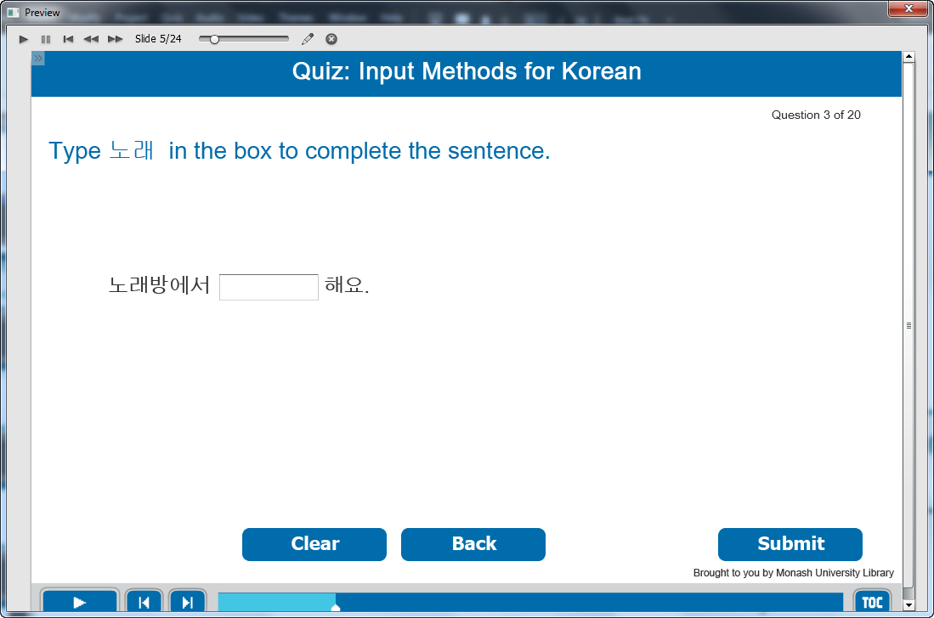

Information caption:
Quiz: Input Methods for Korean.

Guide Me: Type 노래 in the box to complete the sentence.

Instruction caption:
Type the correct answer in fill in the blank box.

Feedback caption:
Please answer the question before continuing.
Correct - Click anywhere or press ‘y’ to continue.
Incorrect - Use the IME to type in Han’gŭl for 노래. Click anywhere or press ‘y’ to continue.

Optional buttons: Click Clear or Back or Submit.

Screen Step 5: Random quiz for input methods for Korean

Image of the quiz screen.

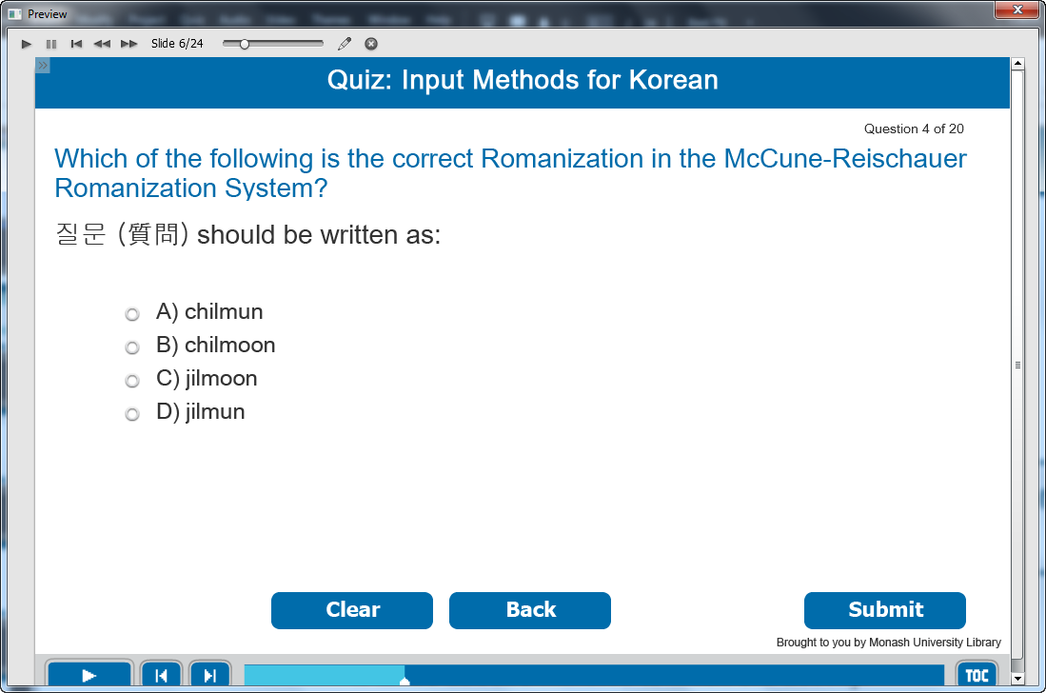

Information caption:
Quiz: Input Methods for Korean.

Guide Me: Which of the following is the correct Romanization in the McCune-Reischauer Romanization System?
질문 (質問) should be written as:

Instruction caption:
Select the correct answer from the multiple choice.

Feedback caption:
Please answer the question before continuing.
Correct - Click anywhere or press ‘y’ to continue.
Incorrect - The correct answer is chilmun. Click anywhere or press ‘y’ to continue.

Optional buttons: Click Clear or Back or Submit.

Screen Step 6: Random quiz for input methods for Korean

Image of the quiz screen.

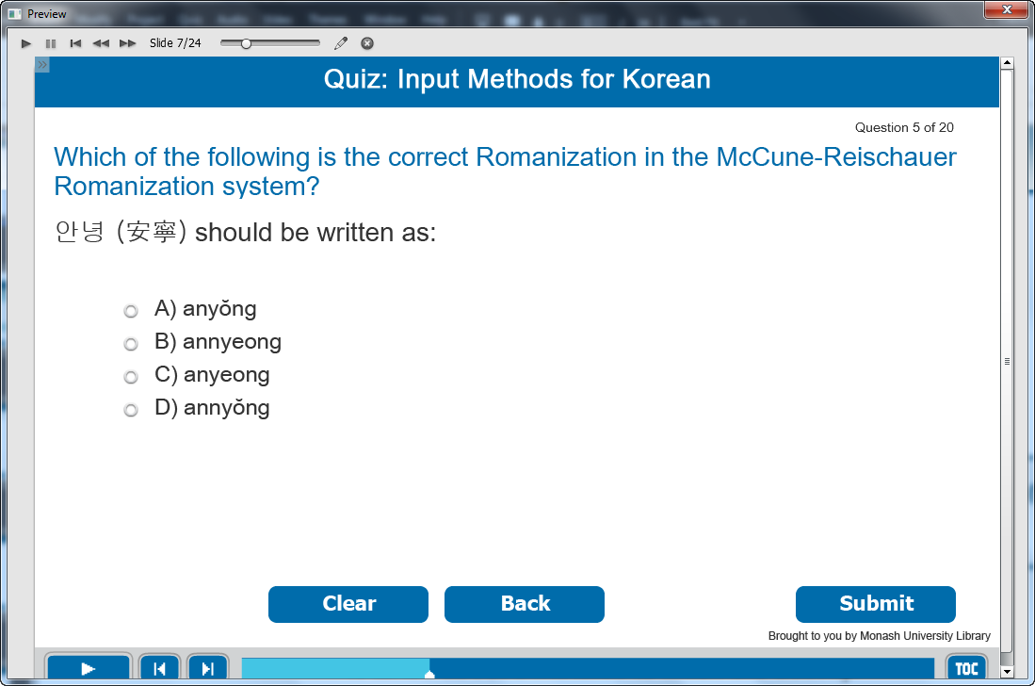

Information caption:
Quiz: Input Methods for Korean.

Guide Me: Which of the following is the correct Romanization in the McCune-Reischauer Romanization System?
안녕 (安寧) should be written as:

Instruction caption:
Select the correct answer from the multiple choice.

Feedback caption:
Please answer the question before continuing.
Correct - Click anywhere or press ‘y’ to continue.
Incorrect - The correct answer is annyŏng. Click anywhere or press ‘y’ to continue.

Optional buttons: Click Clear or Back or Submit.

Screen Step 7: Random quiz for input methods for Korean

Image of the quiz screen.

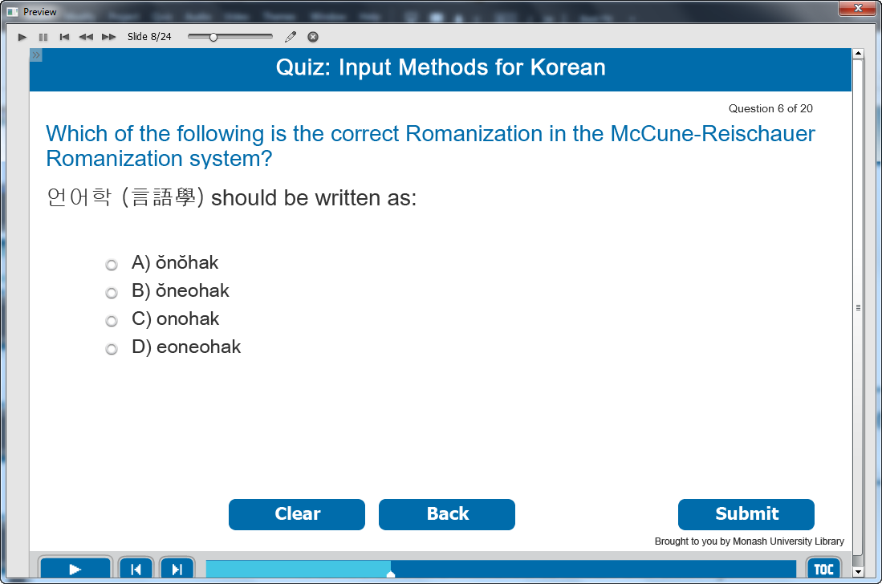

Information caption:
Quiz: Input Methods for Korean.

Guide Me: Which of the following is the correct Romanization in the McCune-Reischauer Romanization System?
언어학 (言語學) should be written as:

Instruction caption:
Select the correct answer from the multiple choice.

Feedback caption:
Please answer the question before continuing.
Correct - Click anywhere or press ‘y’ to continue.
Incorrect - The correct answer is ŏnŏhak. Click anywhere or press ‘y’ to continue.

Optional buttons: Click Clear or Back or Submit.

Screen Step 8: Random quiz for input methods for Korean

Image of the quiz screen.

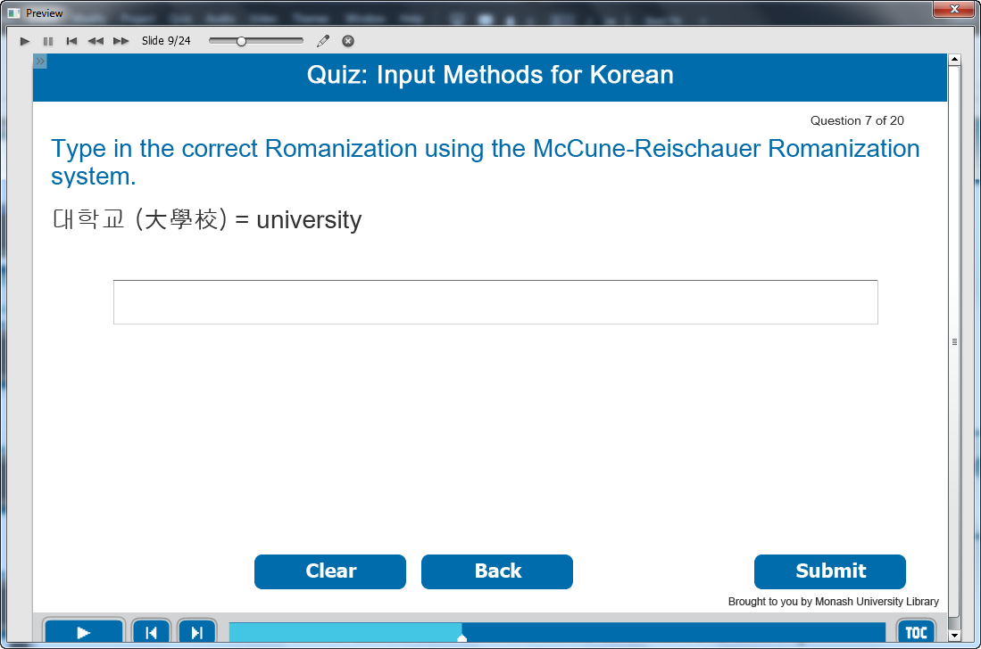

Information caption:
Quiz: Input Methods for Korean.

Guide Me: Type in the correct Romanization using the McCune-Reischauer Romanization system.
대학교 (大學校) = university

Instruction caption:
Fill the correct answer in the box.

Feedback caption:
Please answer the question before continuing.
Correct - Click anywhere or press ‘y’ to continue.
Incorrect - The correct answer is taehakkyo. Click anywhere or press ‘y’ to continue.

Optional buttons: Click Clear or Back or Submit.

Screen Step 9: Random quiz for input methods for Korean

Image of the quiz screen.

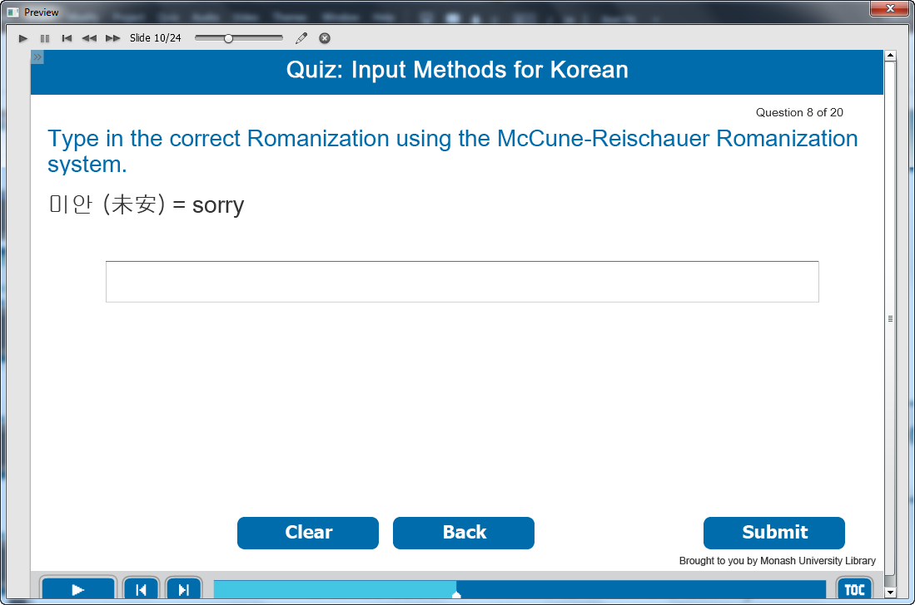

Information caption:
Quiz: Input Methods for Korean.

Guide Me: Type in the correct Romanization using the McCune-Reischauer Romanization system.
미안 (未安) = sorry

Instruction caption:
Fill the correct answer in the box.

Feedback caption:
Please answer the question before continuing.
Correct - Click anywhere or press ‘y’ to continue.
Incorrect - The correct answer is mian. Click anywhere or press ‘y’ to continue.

Optional buttons: Click Clear or Back or Submit.

Screen Step 10: Random quiz for input methods for Korean

Image of the quiz screen.

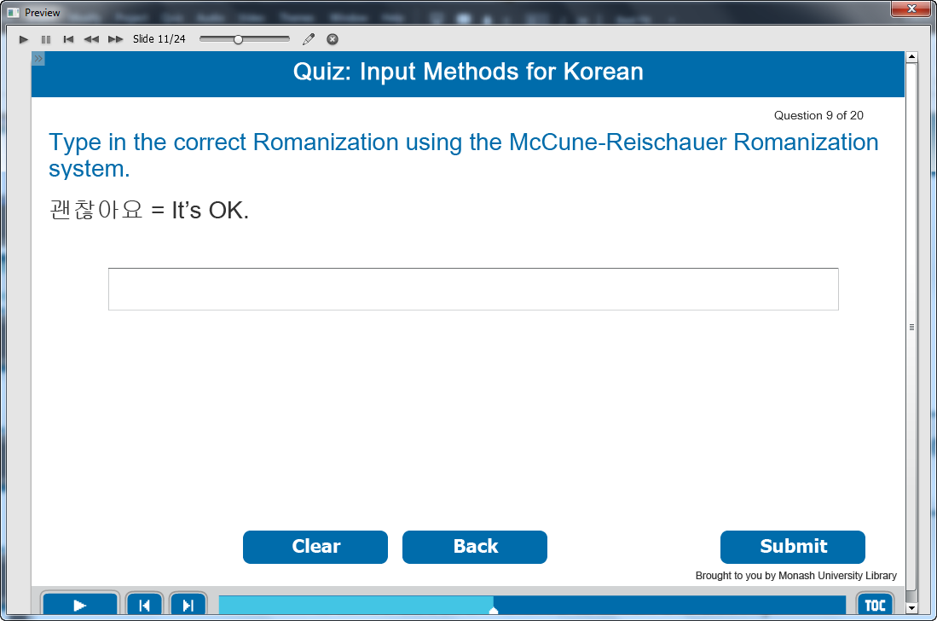

Information caption:
Quiz: Input Methods for Korean.

Guide Me: Type in the correct Romanization using the McCune-Reischauer Romanization system.
괜찮아요 = It’s OK.

Instruction caption:
Fill the correct answer in the box.

Feedback caption:
Please answer the question before continuing.
Correct - Click anywhere or press ‘y’ to continue.
Incorrect - The correct answer is kwaench’anayo. Click anywhere or press ‘y’ to continue.

Optional buttons: Click Clear or Back or Submit.

Screen Step 11: Random quiz for input methods for Korean

Image of the quiz screen.

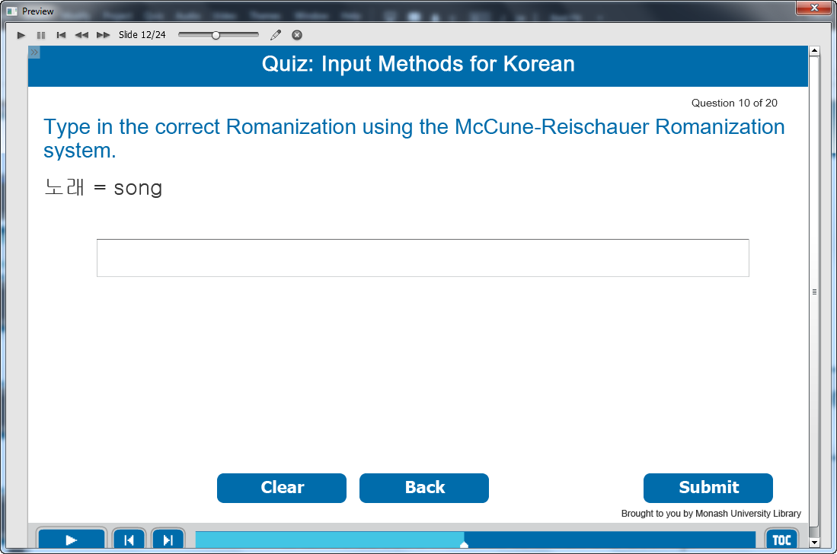

Information caption:
Quiz: Input Methods for Korean.

Guide Me: Type in the correct Romanization using the McCune-Reischauer Romanization system.
노래 = song.

Instruction caption:
Fill the correct answer in the box.

Feedback caption:
Please answer the question before continuing.
Correct - Click anywhere or press ‘y’ to continue.
Incorrect - The correct answer is norae. Click anywhere or press ‘y’ to continue.

Optional buttons: Click Clear or Back or Submit.

Screen Step 12: Random quiz for input methods for Korean

Image of the quiz screen.

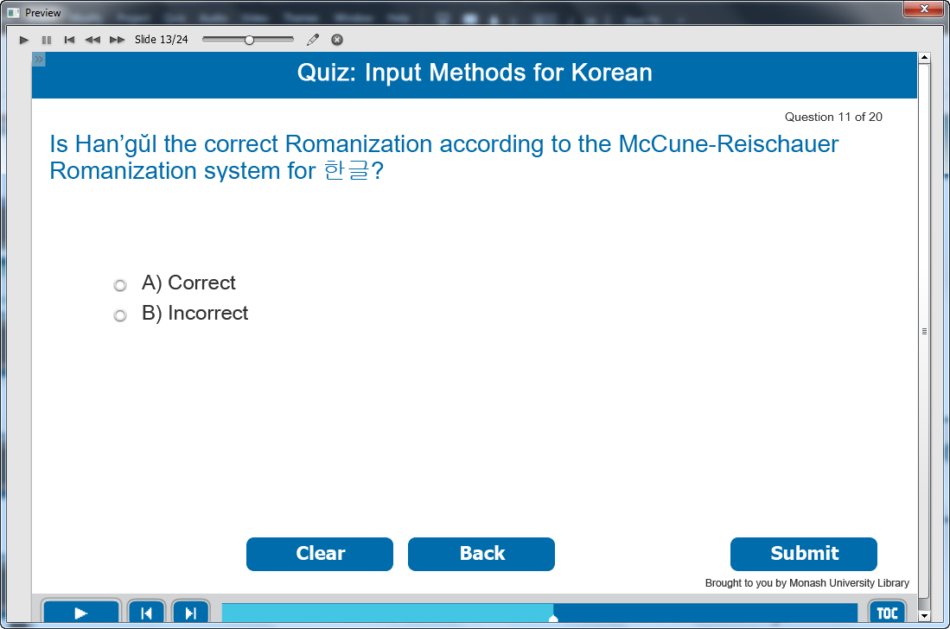

Information caption:
Quiz: Input Methods for Korean.

Guide Me: Is Han’gŭl the correct Romanization according to the McCune-Reischauer Romanization system for 한글?

Instruction caption:
Select the correct answer from the multiple choice.

Feedback caption:
Please answer the question before continuing.
Correct - Click anywhere or press ‘y’ to continue.
Incorrect - Han’gŭl is the correct MR Romanization for 한글. Click anywhere or press ‘y’ to continue.

Optional buttons: Click Clear or Back or Submit.

Screen Step 13: Random quiz for input methods for Korean

Image of the quiz screen.

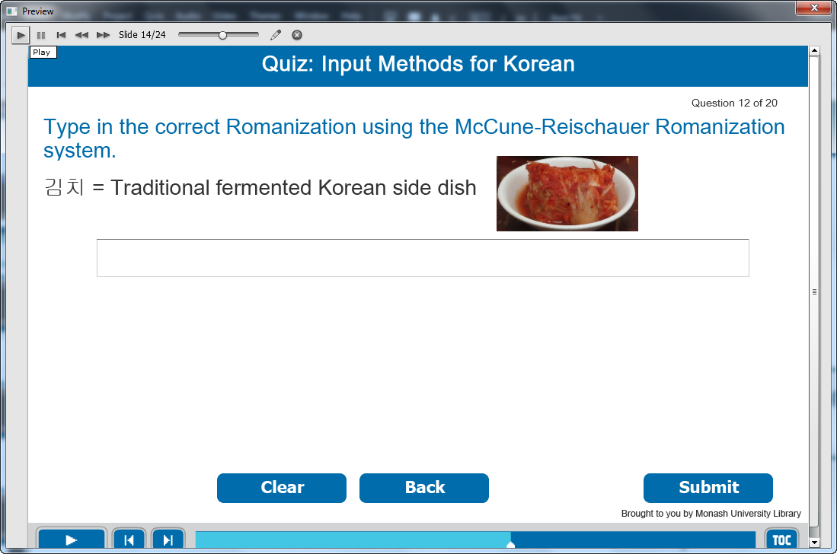

Information caption:
Quiz: Input Methods for Korean.

Guide Me: Type in the correct Romanization using the McCune-Reischauer Romanization system.
김치 = Traditional fermented Korean side dish

Instruction caption:
Fill the correct answer in the box.

Feedback caption:
Please answer the question before continuing.
Correct - Click anywhere or press ‘y’ to continue.
Incorrect - The correct answer is Kimch’i. Click anywhere or press ‘y’ to continue.

Optional buttons: Click Clear or Back or Submit.

Screen Step 14: Random quiz for input methods for Korean

Image of the quiz screen.

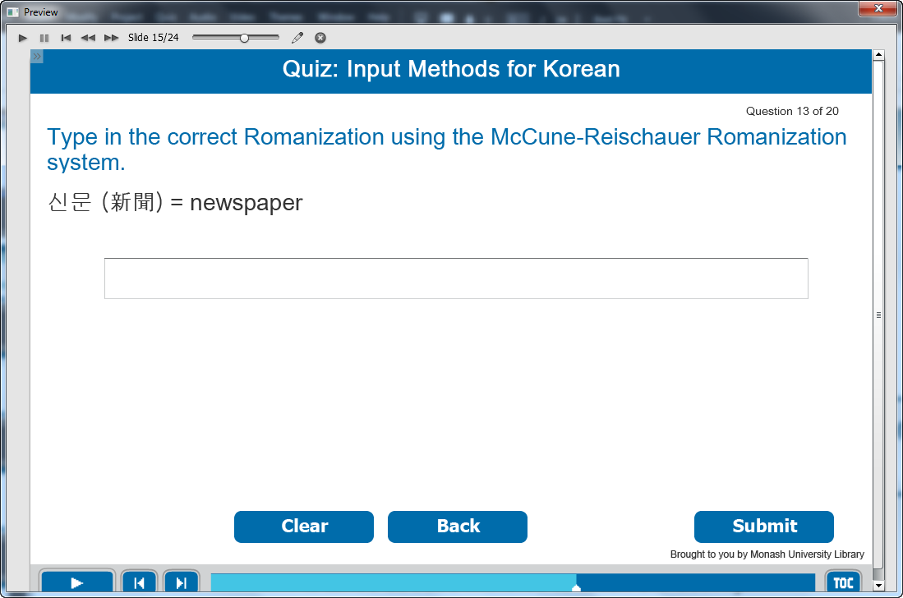

Information caption:
Quiz: Input Methods for Korean.

Guide Me: Type in the correct Romanization using the McCune-Reischauer Romanization system.
신문 (新聞) = newspaper

Instruction caption:
Fill the correct answer in the box.

Feedback caption:
Please answer the question before continuing.
Correct - Click anywhere or press ‘y’ to continue.
Incorrect - The correct answer is sinmun. Click anywhere or press ‘y’ to continue.

Optional buttons: Click Clear or Back or Submit.

Screen Step 15: Random quiz for input methods for Korean

Image of the quiz screen.

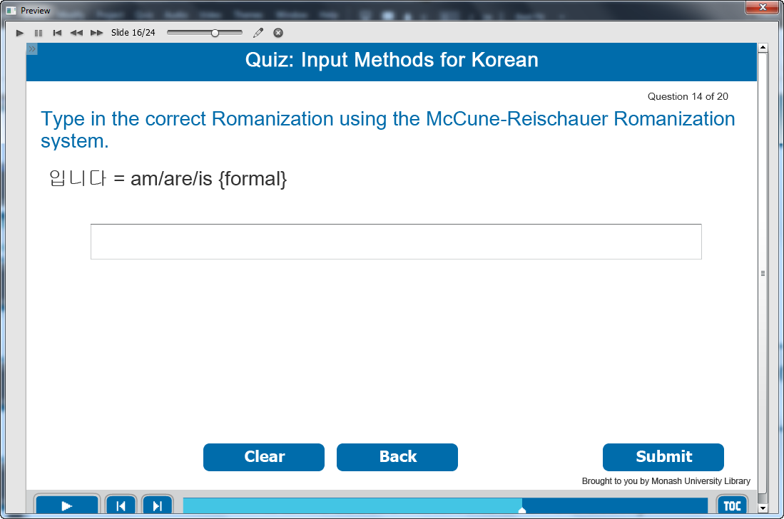

Information caption:
Quiz: Input Methods for Korean.

Guide Me: Type in the correct Romanization using the McCune-Reischauer Romanization system.
입니다 = am/are/is {formal}

Instruction caption:
Fill the correct answer in the box.

Feedback caption:
Please answer the question before continuing.
Correct - Click anywhere or press ‘y’ to continue.
Incorrect - The correct answer is imnida. Click anywhere or press ‘y’ to continue.

Optional buttons: Click Clear or Back or Submit.

Screen Step 16: Random quiz for input methods for Korean

Image of the quiz screen.

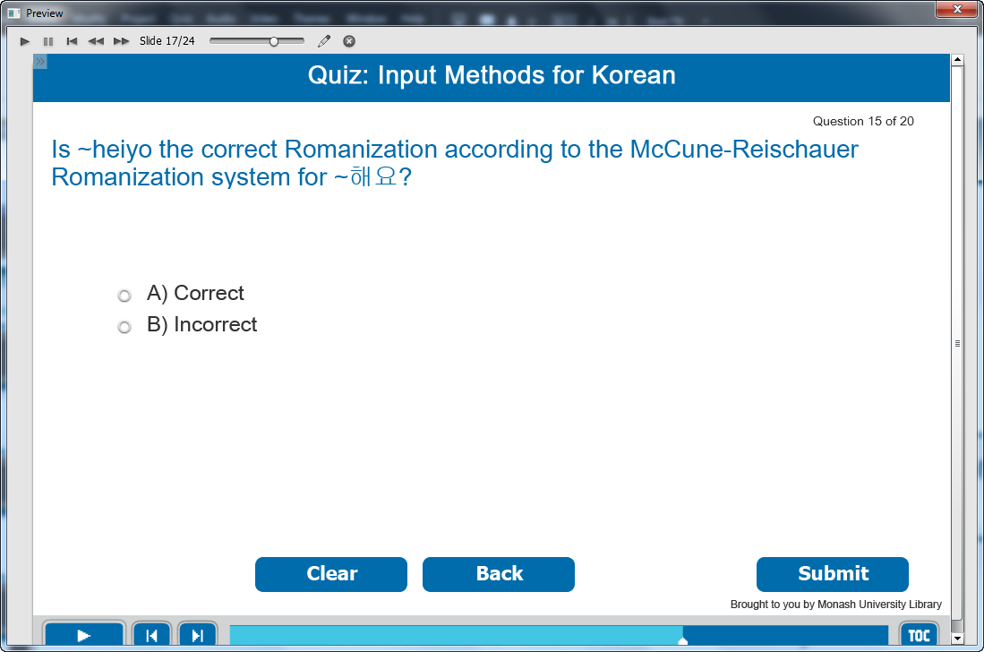

Information caption:
Quiz: Input Methods for Korean.

Guide Me: Is ~heiyo the correct Romanization according to the McCune-Reischauer Romanization system for ~해요?

Instruction caption:
Select the correct answer from the multiple choice.

Feedback caption:
Please answer the question before continuing.
Correct - The correct Romanization for ~해요 is ~haeyo. Click anywhere or press ‘y’ to continue.
Incorrect - ~haeyo is the correct Romanization for ~해요. Click anywhere or press ‘y’ to continue.

Optional buttons: Click Clear or Back or Submit.

Screen Step 17: Random quiz for input methods for Korean

Image of the quiz screen.

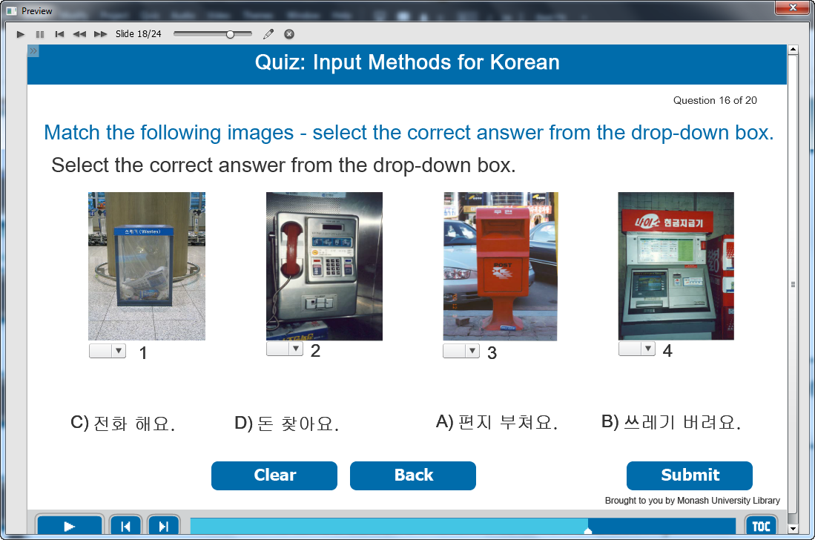

Information caption:
Quiz: Input Methods for Korean.

Guide Me: Match the following Korean writing systems with the words on the right.

Instruction caption: Select the correct answer from the drop-down box.

Feedback caption:
Please answer the question before continuing.
Correct - Click anywhere or press ‘y’ to continue.
Incorrect - The correct answer is 1: 쓰레기 버려요, 2: 전화해요, 3: 편지 부쳐요, 4: 돈 찾아요. Click anywhere or press ‘y’ to continue.

Optional buttons: Click Clear or Back or Submit.

Screen Step 18: Random quiz for input methods for Korean

Image of the quiz screen.

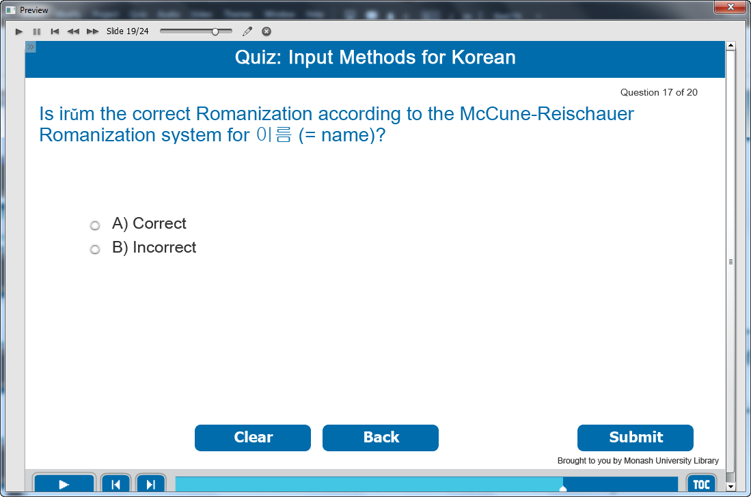

Information caption:
Quiz: Input Methods for Korean.

Guide Me: Is irŭm the correct Romanization according to the McCune-Reischauer Romanization system for 이름 (= name)?

Instruction caption:
Select the correct answer from the multiple choice.

Feedback caption:
Please answer the question before continuing.
Correct - Click anywhere or press ‘y’ to continue.
Incorrect - irŭm is the correct MR Romanization for 이름 (= name). Click anywhere or press ‘y’ to continue.

Optional buttons: Click Clear or Back or Submit.

Screen Step 19: Random quiz for input methods for Korean

Image of the quiz screen.

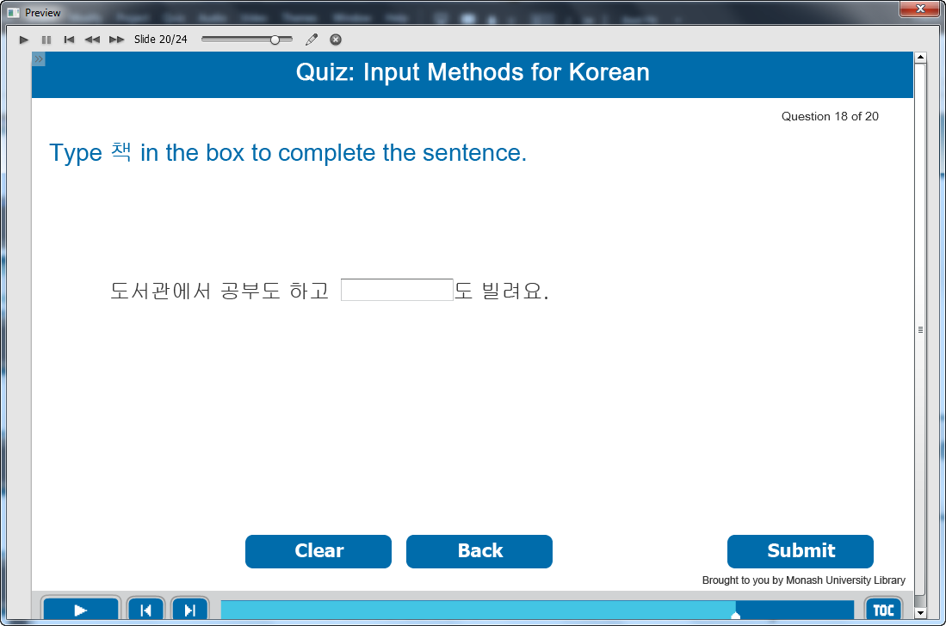

Information caption:
Quiz: Input Methods for Korean.

Guide Me: Type 책 in the box to complete the sentence.

Instruction caption:
Type the correct answer in fill in the blank box.

Feedback caption:
Please answer the question before continuing.
Correct - Click anywhere or press ‘y’ to continue.
Incorrect - The correct answer is 책. Click anywhere or press ‘y’ to continue.

Optional buttons: Click Clear or Back or Submit.

Screen Step 20: Random quiz for input methods for Korean

Image of the quiz screen.

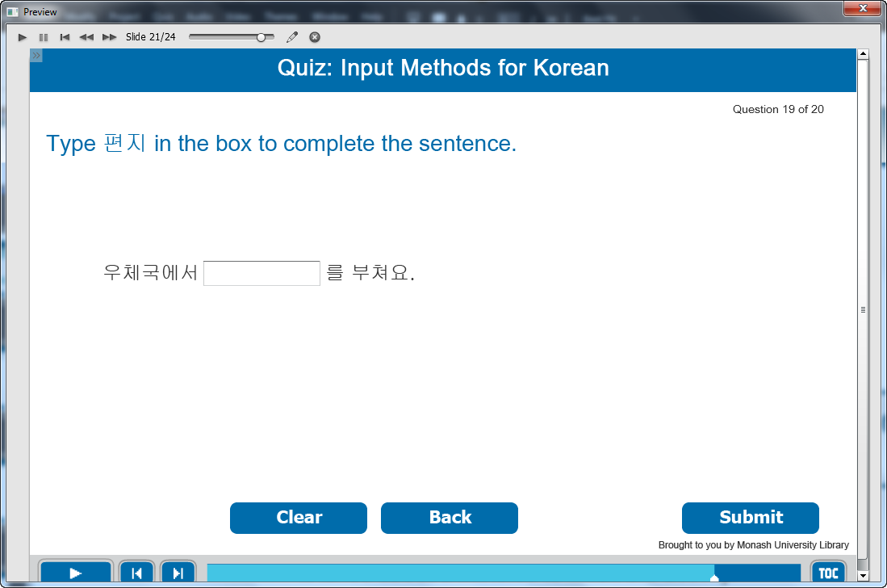

Information caption:
Quiz: Input Methods for Korean.

Guide Me: Type 편지 in the box to complete the sentence.

Instruction caption:
Type the correct answer in fill in the blank box.

Feedback caption:
Please answer the question before continuing.
Correct - Click anywhere or press ‘y’ to continue.
Incorrect - The correct answer is 편지. Click anywhere or press ‘y’ to continue.

Optional buttons: Click Clear or Back or Submit.

Screen Step 21: Random quiz for input methods for Korean

Image of the quiz screen.

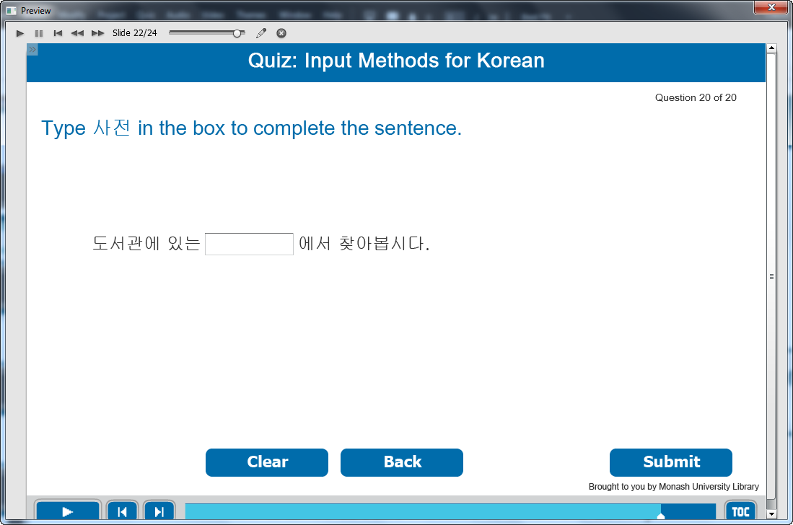

Information caption:
Quiz: Input Methods for Korean.

Guide Me: Type 사전 in the box to complete the sentence.

Instruction caption:
Type the correct answer in fill in the blank box.

Feedback caption:
Please answer the question before continuing.
Correct - Click anywhere or press ‘y’ to continue.
Incorrect - The correct answer is 사전. Click anywhere or press ‘y’ to continue.

Optional buttons: Click Clear or Back or Submit.

Screen Step 22: Well done!

Image of Well done screen.

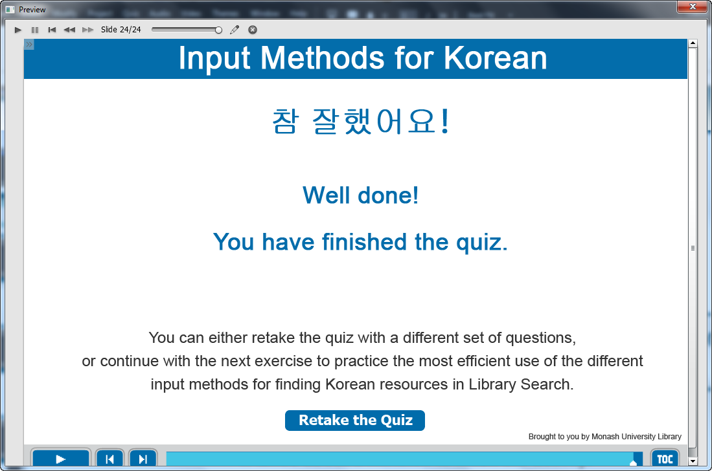

Information captions:
Input Methods for Korean.
참 잘했어요 !
Well done!
You have finished the quiz.
You can either retake the quiz with a different set of questions,
or continue with the next exercise to practice the most efficient use of the different input methods for finding Korean resources in Library Search.

Instruction caption: Click “Retake the Quiz” to go back to the beginning of the quiz.

